*Comprehensive Data Resource (CDR*) User Guide

Version 0.7

2/19/2015

DRAFT

**Version History**

This document combines information from a variety of existing sources in describing the design and context under which the Comprehensive Data Resource operates. This document is consistent with version 6.0 of the CDR.

|  |  |  |  |  |  |
| --- | --- | --- | --- | --- | --- |
| **Version Number** | **Implemented**  **By** | **Revision**  **Date** | **Approved**  **By** | **Approval**  **Date** | **Description of Change** |
| 0.2 | *William Brent Lander* | *1/11/2016* |  |  | *Working initial draft* |
| 0.2 | Dave Tabor | 01/06/2016 |  |  | Review |
| 0.5 | *William Brent Lander* | 1/29/2016 |  |  | *Section complete version submitted for review* |
| 0.6 | Dave Tabor | 2/19/2016 |  |  | Review |
| 0.65 | Karna Robinson | 2/19/2016 |  |  | Data Management Review |
| 0.7 | Brent Lander | 2/19/2016 |  |  | Merged 0.5, 0.6, 0.65 |
|  |  |  |  |  |  |
|  |  |  |  |  |  |

TABLE OF CONTENTS

1 Introduction 1

2 CDR Basics 1

2.1 CDR Capabilities 1

2.2 CDR Accounts, Roles and Responsibilities 2

2.3 Logging Into and Out of the CDR 4

2.3.1 Important Login Screen Links 4

2.4 Automatic Log Out 5

3 Basic Data Entry, the role of the Biospecimen/Tissue Source Site 5

3.1 Process Overview 5

3.1.1 The Study Home Page 6

3.1.2 Search 8

3.2 Case List 11

3.3 Candidate List 12

3.4 Uploading Files 12

3.4.1 Process 12

3.5 Downloading a File 13

3.6 Submitting the Case for Review and Processing 13

3.6.1 Process 13

3.6.2 Workflow 14

3.7 Responding to Irregularities found in Review: The Query Tracker 14

3.7.1 Process 15

3.8 Adding a New Candidate 16

3.8.1 Process 16

3.9 Adding a Screening Enrollment Form to a Candidate 18

3.9.1 Process 18

3.10 Candidate Consent Form 20

3.10.1 Process 20

3.11 Entering Candidate Demographics Form 23

3.11.1 Process 23

3.12 Entering Candidate Health History Form 26

3.12.1 Process 26

3.13 Entering Candidate Social History Form 30

3.13.1 Process 30

3.14 Adding Candidate Case Records 32

3.14.1 Process 32

3.15 Adding a Blood Collection and Processing Form 34

3.15.1 Process 34

3.16 Adding a Surgery Anesthesia Form 38

3.16.1 Process 38

3.17 Adding a Tissue Gross Evaluation Form 41

3.17.1 Process 41

3.18 Adding a Tissue Receipt and Dissection Form 44

3.18.1 Process 44

3.19 Adding a Tissue Preservation Form, a.k.a., Adding Specimens 46

3.19.1 Process 46

3.20 Adding a Tissue Processing-Embedding Form 48

3.20.1 Process 48

3.21 Adding a Slide Sectioning Form, a.k.a. Adding Sides 51

3.21.1 Process 51

3.22 Adding a Slide Prep and Staining Form 53

3.22.1 Process 53

3.23 Adding a Surgical Pathology Form 55

3.24 Adding a Clinical Data Entry Form 56

3.24.1 Process 56

4 PRC Role 61

4.1 Pathology Case Summary Report 62

4.1.1 Process 62

5 DM Role 65

5.1 Setting/Clearing the DM role flag 65

5.1.1 Process 65

5.2 Understanding the Data Management Home page 66

5.3 Using the Query Tracker tool 67

5.3.1 Process 67

5.4 Creating a New Query 67

5.4.1 Process 67

5.5 Viewing an Existing Query 69

5.5.1 Process 69

5.6 Closing Existing Query 69

5.6.1 Process 69

5.7 Using the User Login History tool 71

5.7.1 Process 71

5.8 Using the Vocabulary tool 72

5.8.1 Process 72

6 LDS Role 76

6.1 Setting/Clearing the LDS role flag 76

6.1.1 Process 76

7 Administrative Role 77

7.1 Overall Process for Creating a New Study in CDR 77

7.1.1 Process 77

7.2 Adding a New Study Record 78

7.2.1 Process 78

7.3 Adding an Organization 79

7.3.1 Process 79

7.4 Associating a Study with a BSS 82

7.4.1 Process 82

7.5 Administering Users 83

7.5.1 Process 83

7.6 Administering Application Settings 88

7.6.1 Process 88

7.7 Modifying Tissue List for Including New Types of Specimens 89

7.7.1 Process 89

7.8 Modifying the list of Organizations 90

7.8.1 Process 90

**Table of Figures**

Figure 1 - The CDR in Context of the GTEx Study 2

Figure 2 - CDR Login 4

Figure 3 - Basic Data Entry Page Flow 5

Figure 4 - Example Study Home Page 6

Figure 5- Example CaseRecord List 7

Figure 6- Example CandidateRecord List 8

Figure 7 - Search Home Screen 9

Figure 8 - Uploaded Files Line of Case Record Details Screen 13

Figure 9 - Screen for Upload PDF or ZIP File Selection 13

Figure 10 - Upload Files List Row on the Case Record Details Screen 13

Figure 11 - Example of an Attempt to Submit a Form with Missing Required Fields 14

Figure 12 - Query List 15

Figure 13- Example Home Screen with Case Steve1 having a Query Pending 15

Figure 14 - Query List, with Case Details for the Query on Case Steve1 16

Figure 15 - Adding a Candidate from the Study Home Page 16

Figure 16 - Create New Candidate Record Form 17

Figure 17 - Example View Candidate Record Details 17

Figure 18 - Study Home Page With One Candidate in List 18

Figure 19 - Create Candidate Screening Enrollment Form 18

Figure 20 - Example Edit Candidate Screening Enrollment Form 19

Figure 21 - Updated View Candidate Record Details 20

Figure 22 - Study Home Page, Where Candidate Needs Consent Added 20

Figure 23 - Candidate Details where Consent Verification Needed 21

Figure 24 - Create Candidate Consent Validation Form 22

Figure 25 - Expanded View Candidate Record Details Form 23

Figure 26 – Create Candidate Demographics Form 24

Figure 27 - Expanded View Candidate Record Details 25

Figure 28 - Show Demographics for Candidate with Resume Edit button 26

Figure 29 - Create Health History Form 27

Figure 30 - Show Health History Screen 28

Figure 31 - Form for Entering Health History Details 28

Figure 32 - Create General Medical History Record Fields 29

Figure 33 - Medications History List for a Candidate 30

Figure 34 - Additional Fields for Creating an Entry in the Medications History 30

Figure 35 – Create Social History Screen 31

Figure 36 - Creating a Case Record for a Candidate 32

Figure 37 - Show Case Record Details screen 33

Figure 38 - Change Case Status Screen 34

Figure 39 - Editing a Blood Form 34

Figure 40 - Edit Blood Draw Screen 36

Figure 41 – Surgery Anesthisia Form 39

Figure 42 - Create Tissue Gross Evaluation Screen 41

Figure 43 - Expanded Create Tissue Gross Evaluation Form 43

Figure 44 - Additional Tissue Gross Evaluation Fields for Tissue Bank 44

Figure 45 - Creating a Tissue Receipt and Dissection 45

Figure 46 – Creating/Adding Specimens Form 47

Figure 47 - Creating Save Tissue Processing-Embedding Form for a Case 49

Figure 48 - Creating a Slide Sectioning Form for a Case 52

Figure 49 - Ancillary Window for Entering Slide ID and Associated Specimen ID 52

Figure 50 - Creating a Slide Prep form 54

Figure 51- Upload Surgical Pathology Form 56

Figure 52 - Creating a Clinical Data Entry Form for a Case 57

Figure 53 - Expanded Question 4 for Entering Details of Radiation Therapy 58

Figure 54 - Expanded Question 5 for Entering Details of Chemotherapy 59

Figure 55 - Expanded Question 6 for Entering Details of Immunotherapy 59

Figure 56 - Expanded Quesion 7 for Hormonal Therapy 60

Figure 57 - Expanded Question 14 for Karnofky Score 60

Figure 58 - Expanded Question 14 for Eastern Cancer Oncology (ECOG) Score 61

Figure 59 - Enabling PRC Role (Green Arrow) and Message 62

Figure 60 - Study Specific (WBL) PRC Home screen 63

Figure 61 - Edit PRC Report Screen 64

Figure 62 - Home screen, with Green Arrow indicating Location of DM flag 66

Figure 63 - DM Home Screen 66

Figure 64 - Query List Screen in the Query Tracker 67

Figure 65 - Create Query Screen 68

Figure 66 - Show Query after a new Query Creation 69

Figure 67 - Show Query Addressed Query . Note Additional Buttons at Bottom. 71

Figure 68 – CDR User Login History tool 72

Figure 69 - CDR-Lite Data Services Vocabulary and Configuration 73

Figure 70 - BloodDrawType List (Example of modifying vocabulary Lists) 75

Figure 71 - Create BloodDrawType Screen 75

Figure 72 - Show BloodDrawType after Adding New Type 76

Figure 73 - Home Screen, with Green Arrow Indicating Location of LDS flag 77

Figure 74 - Study List Screen with Two Example Studies 78

Figure 75 - Create Study Window 78

Figure 76 - Adding The DM Role in Adding an Organization 79

Figure 77 - Accessing Administrative Vocabulary items 79

Figure 78 - CDR-Lite Data Services Vocabulary and Configuration showing Organization 80

Figure 79 - Organization List, with New Organization indicated 80

Figure 80 - Create Organization screen 81

Figure 81 - Show Organization Screen 82

Figure 82 – Show An Individual Study Screen 82

Figure 83 - Edit Study Screen 83

Figure 84 - CDR Project Home Destination Page 84

Figure 85 - CDR Back Office 84

Figure 86 - Spring Security Management Console 85

Figure 87 - Create User, User Detail 86

Figure 88 - Create User - Roles 87

Figure 89 - Determining Which Users have a specifie Role 88

Figure 90 - CDR Applications Setting List 89

**Table of Tables**

Table 1 - Roles and Capabilities Associated with Them 3

Table 2 - Login Screen Important Information 4

Table 3 - Upper Right Corrner Screen Links 8

Table 4 - Search Operators 9

Table 5 - Definition of fields in Case List 11

Table 6 - Definition of Fields in Candidate List 12

Table 7 - Vocabulary Items and Access Restrictions 73

Table 8 - Types of users required for each study 83

Table 9 - CDR Basic Applications Settings 88

# Introduction

The Comprehensive Data Resource (CDR) was developed to meet the challenges of real-world data collection of information about tissues gathered in the early stages of the Biospecimen Lifecycle[1] . This includes collection of information about potential candidates, their eligibility criteria and consent, medical history, surgical procedures used, acquisition, processing, handling, and storage. As the focus for biospecimen-based studies for cancer have turned to the molecular level, it is more important than ever that more comprehensive biospecimen annotation be collected during biospecimen acquisition.

# CDR Basics

## CDR Capabilities

The CDR is a web-based application, custom built to support specimen collection, clinical data entry and specimen logistics as well as curation and aggregation of study data. The capabilities reflect the needs of the supported projects, and include:

* Allowing remote users (e.g., researchers, and support staff) to securely enter, revise, and review data about biospecimen collection through a standard (HTTPS) web interface via a series of electronic forms with a sophisticated role-driven workflow.
* Connecting to remote systems via Web service APIs; such as LIMS, whole-slide imaging systems, and molecular analysis systems
* E-mail alerts automatically communicate timely information to project managers and data analysts, letting them know when to start working on something.
* Assisting Quality Assurance by auditing process flows through Data Management and Pathology teams
* Controlling display of Personally Identifiable Information (PII) or Personal Health Information (PHI) based on user entitlements and roles

GTEx source materials provide Figure 1. The CDR acts as a data hub:

* Storing information about the geographically diverse collections from the BSS,
* Transferring and processing through the CBR,
* Handing off information to both the Brain Bank and Molecular Analysis Facility

The gray lines show the flow of biospecimens; the flow of information about the collections. The specimens themselves show in blue. When the BSS collects tissues, they use the forms hosted by the CDR in describing the case, biospecimens, and other clinical information. As the biospecimens transfer to the CBR, the CDR receives inventory information on those collected biospecimens (through web service messages) from the informatics system at the CBR. This instantiates workflows and creates triggers for data managers and pathologists to review cases. Once the tissues are processed, the CBR records subsequent transfer of materials to other, specialized, labs, including the Laboratory Data Analysis & Coordinating Center (LDACC) for molecular studies. Results of various tests at these specialized labs also enter into the CDR via web services or user input, providing comprehensive study information

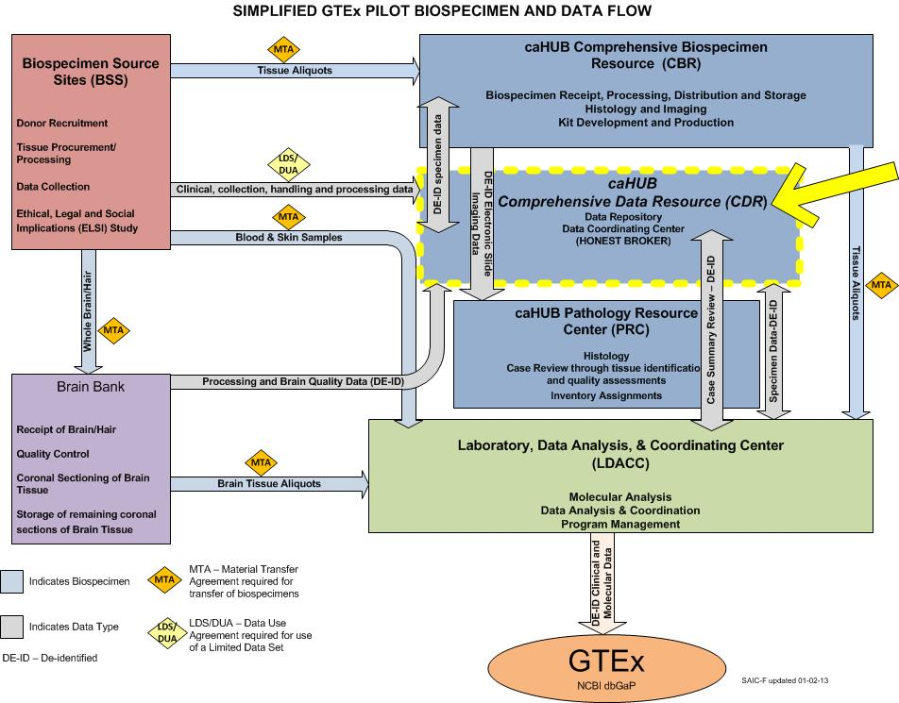

Figure 1 - The CDR in Context of the GTEx Study

## CDR Accounts, Roles and Responsibilities

The following table connects three different key elements of CDR. Individuals have unique accounts. Those accounts may be authorized with certain roles those users may perform. The responsibilities are the activities those users will do when exercising those roles.

Table 1 - Roles and Capabilities Associated with Them

| Role | Only own org data | Read Only | Can View LDS | Create Candi-date | Change Status | View Query List | New Query | Memo | Create User | Create Case | Case File Up-load | Case File Down load | Case File Edit | General File Up-load | General File Down-load | General File Edit |
| --- | --- | --- | --- | --- | --- | --- | --- | --- | --- | --- | --- | --- | --- | --- | --- | --- |
| BSS_ROLE | x |  | x | x | Initialized, Data Entry Underway, DE Complete, Remediation | x |  | x |  | x | x | x | only files up-loaded | x | x | only files up-loaded |
| BCR_ROLE | x | x |  |  |  |  |  | read only |  |  |  |  |  |  |  |  |
| DCC_ROLE | x | x |  |  |  |  |  |  |  |  |  |  |  |  |  |  |
| DM_ROLE* |  | x |  |  | x | x | x | x | x |  | x | x | * | x | x | x |
| QM_ROLE* |  | x |  |  |  |  |  | x |  |  |  | x |  | x | x |  |
| LDS_ROLE* |  | x | x |  |  |  |  | read only |  |  |  | x |  | x | x |  |
| PRC_ROLE* |  |  |  |  | Pathology Review Underway, Pathology Review Complete |  |  | read only |  |  |  | x |  | x |  |  |

All users with DM, QM or ADMIN roles also need the DM_ROLE.

* Same as internalUser except as noted

## Logging Into and Out of the CDR

When going to the CDR web site, the first page is always the login page.

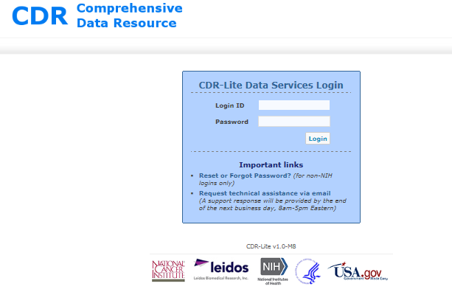

Figure 2 - CDR Login

**Note: On your initial login to the production site, the password must be changed.**

Both **Login ID** and **Password** are case sensitive. Accounts lock automatically after a number of unsuccessful tries. In this case, contact the CDR administrator and request help regarding the Password Change and Recovery process.

Click on the word **Logout** at the upper right corner of any CDR screen to logout. Upon logout, whether automatic or intentional, the CDR Login screen appears.

If CDR does not update the browser session for some time (typically 30 minutes), then the session automatically logs out; any unsaved is lost.

### Important Login Screen Links

At the bottom of the screen are various links for going to auxiliary sites such as recovery of passwords and an email link for requesting help.

Table 2 - Login Screen Important Information

| **Link/Information** | **Description** |
| --- | --- |
| **Forgot Password?** | The "**Forgot Password?"** link on the Home screen brings up a small window into which you can enter your user name. An email goes to your email address on record for completion of the password change, or recovery process. |
| **Request Help via Email** | This link opens your email client for sending a request for help to ncicahub_help@mail.nih.gov. |
| **Getting the CDR Version Number** | At the bottom of the Login screen (and every screen) is the CDR version number. When describing any problems, it is very important that you include this number. |

## Automatic Log Out

If a CDR web session is inactive for 30 minutes, the system automatically logs out the user. Any information entered, but not saved, on the form in process, will be lost.

# Basic Data Entry, the role of the Biospecimen/Tissue Source Site

## Process Overview



Figure 3 - Basic Data Entry Page Flow

Figure 3 shows the progress of data entry into the CDR, as it relates to the case status. The first case status is in light gray, because at that point, there is no case, just a patient that might become a candidate. The Show Case Record Details screen, Figure 37, shows the case status, and allows setting that value appropriately.

The biospecimen source site, or BSS, performs the basic data entry. After logging in, the CDR shows the Home page for that study. Initially, the user may create a candidate. Subsequently, the user increases the information about the candidate’s eligibility. If the findings for the candidate indicate meeting eligibility criteria, then the candidate progresses to a case. Additional forms add details about collection and processing of specimens.

When submitting a form, that form is queued for review by data management. The form review may have issues. If so, a Query starts against that issue. The BSS must respond to the query in a timely manner.

### The Study Home Page

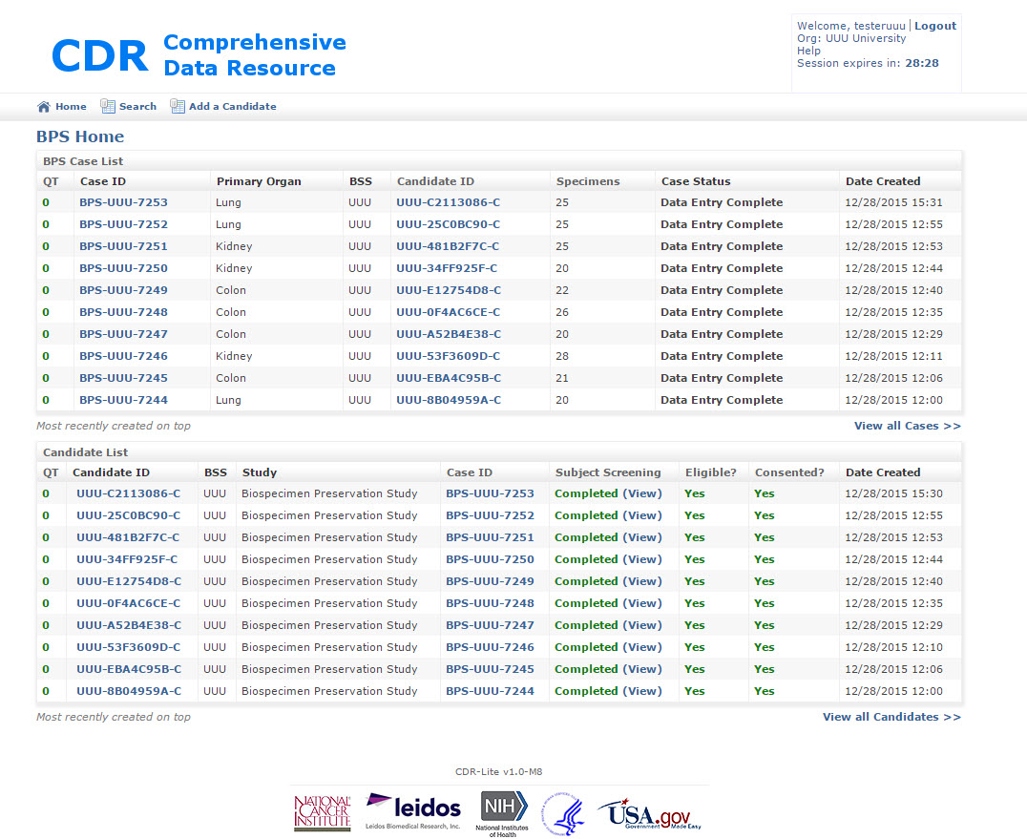

Figure 4 - Example Study Home Page

This is the first page for BSSs after logging into CDR. Clicking on the Home icon in the upper left of the screen causes CDR to go to this screen at any time. The home screen displays a wealth of information for the most recent 10 cases and candidates. Alternatively, the View All Candidates or View All Cases links browse the full list of candidates and cases.

There are two lists on this page: the Study Case List, and the Candidate List.

The Study Case List displays the last few cases entered in this study. The cases list by date of start for the entry, the most recent one first. The columns in the Study Case List show in Table 5. At the bottom of the table, there is a link, **View all Cases >>**. Clicking on this link shows the CaseRecord List screen, where every case lists by Case ID, Figure 5. If the user logged in has the ROLE_BSS flag set, then only those cases associated with the BSS show. Clicking on the Case ID or Candidate Id changes the screen, showing the appropriate details. Query tracker information is not available on the CaseRecord list screen.

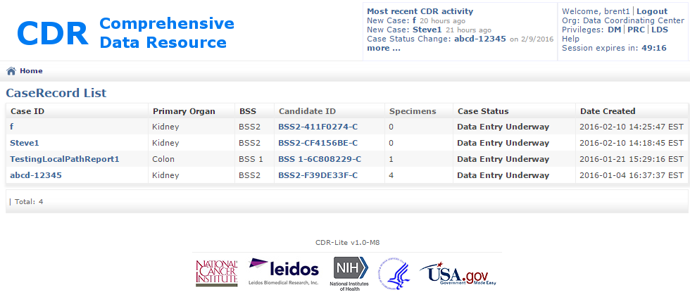

Figure 5- Example CaseRecord List

The column headers in the study candidate list show in Table 6. An example CandidateRecord List screen is in Figure 6. If the user logged in has the ROLE_BSS flag set, then only those candidates associated with the BSS show. Clicking on the Case ID, Candidate Id, and either View or Start moves to the screen showing the appropriate details, however query tracker information is not available.

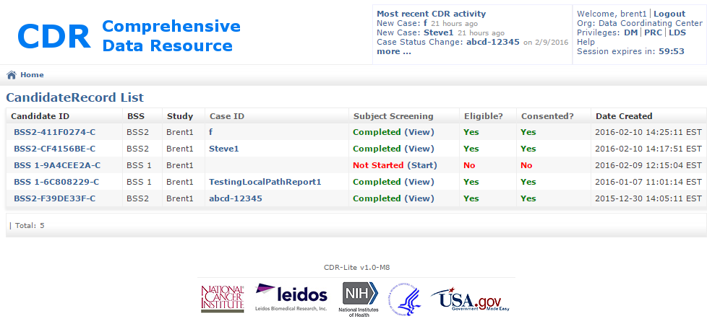

Figure 6- Example CandidateRecord List

**Important Home Screen Links**

Several links are available at the top of the Project Home Page. There is a description of each link elsewhere in this guide. They are:

* Home
* Add New Candidate
* Search

**Upper Right Screen Links**

In the upper right corner of the home screen and all CDR DS screens a number of useful information items and links appear.

Table 3 - Upper Right Corrner Screen Links

| **Information Item** | **Description** |
| --- | --- |
| **Login Name and Organization** | Note that your individual Login ID and organization name appear there. As a BSS user, you only see cases and candidates from your organization. If the account is for a Biospecimen Source Site (BSS), only candidates and cases associated with that BSS are visible. |
| **Help (Email)** | The help link takes you to a page for creating an email to send to the CDR Admin. |
| **“Session expires” Time** | Because NCI mandates automatic logout for sessions with 30 minutes of inactivity, this feature is extremely useful, indicating the number of minutes and seconds until logout. To reset the time available, simply save any form or change from one CDR page to another. This text field turns red when less than 5 minutes remain before automatic logout. |
| **Search** | Section 3.1.2 discusses the search function in detail. |

### Search

The CDR has a powerful search capability. Clicking the **Search** link in the upper right corner of any screen brings up the Search Home screen, for setting up your search.

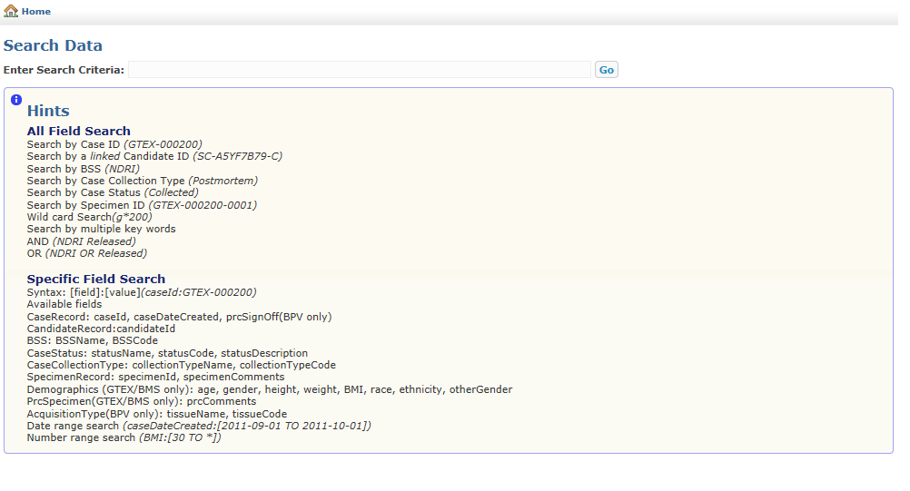

Figure 7 - Search Home Screen

You can search for any character string in any candidate or case information and, of course, any of the text strings appearing on the Home Screen and the View All views. For example, to find case BPV-000004, simply enter that text and click on **Go**.

Simple Search supports search operators. Table 4 - Search Operators, summarizes queries and their anticipated results.

Table 4 - Search Operators

| **Simple Search Operators** | **Example** | **Results** |
| --- | --- | --- |
| **Double quotes** (" ") will return specimens that contain the exact phrase quoted, in any of the fields. | **"Research Institute"** | Comments anywhere containing the exact phrase Research Institute  **Note:** Some fields may contain spaces, so searches should use double quotes. |
| An **asterisk (*)** is a *wild-card* search operator that can replace any number of characters in a search term.  Asterisks are useful in the beginning, middle, or end of a search term.  In a quoted string, asterisks are not wildcards. | **caseID:GTEX-100*5** | This will find a range of GTEx cases. |
| A **question mark (?)** is a *wild-card* search operator replacing a single character in the search term.  Question marks as wildcards are valid in the beginning, middle, or end of a search term. When using multiple question marks within a single search term, each will match one character. Question marks in quoted strings are not wildcards. | **BSSname:ABC???** | Returns information related to a BSS whose name is six symbols long, and starts with “ABC”. |
| A **tilde (~)** is a search operator that will return terms that are spelled similarly to the term that prefaces it.  It should follow a single word search term. | **BSSName:Nat~** | Specimens containing the terms **National or Nationwide** in the PRC Comments field |
| Combine search operators by using parentheses to group queries. | **“2 pieces” AND (internal OR external)** | Specimens containing **2 pieces** and either **internal** or **external** |
| Prefacing a search phrase with **BSSName:** limits the query for the search phrase to the BSSName field. Generally, this matches multiple cases.  Other search terms include:  caseId  candidateId  BSSName  BSSCode  statusName  statusCode  statusDescription  collectionTypeName  collectionTypeCode  tissueName  tissueCode | **BSSName:** “Specimens R Us” | All specimens from BSSs with the name “Specimens R Us” |
| **Compound Searches**  **Any set of the above single searches can combined, making searches more focused, using the following notations.** **The examples all use single words, for clarity, but any of the above is acceptable.** | | |
| Including **AND** or **+** between search phrases will return images that contain both search phrases.  When entering more than one search term, this search operator applies, as the default.  If the operator is in a quoted string, it is not an operator. | **muscle AND skeletal**  or  **muscle + skeletal**  or  **muscle skeletal** | Comments anywhere containing both **muscle** and **skeletal** |
| Including **OR** between search phrases will return images that contain either, or both, search term. | **BSSName:(AAA OR BBB)** | BSS name is either **AAA,** or **BBB,** or both. |
| Including **NOT** or **-** (minus)between search terms will return images that do not contain the term that follows the operator.  This operator requires a search term that returns results. The dash by itself has no meaning.  Operator is in a quoted string, are not treated as operators. | **cortex NOT brain** | Comments anywhere containing **cortex** but not **brain**  The **–** must be between terms; **- brain** will not work |

## Case List

The **Case List** section of the Home Screen provides access to all cases that have not denied or withdrawn consent.

Table 5 - Definition of fields in Case List

| **Case List Field** | **Definition** |
| --- | --- |
| **QT** | Short for “Query Tracker” If there are no queries pending against this individual case, the number zero (“**0**”) shows in green. Otherwise, the count of queries pending shows in red (e.g., “**5**”). Clicking on this non-zero number moves the screen to the Query List for Case Details, XXX. |
| **Case ID** | The unique ID assigned to each case. |
| **Primary Organ** | The source of the tissue collected from the candidate. |
| **BSS** | Abbreviation for the BSS associated with the candidate. |
| **Candidate ID** | Specifies the Candidate ID linked to this case. |
| **Specimen Count** | This column indicates the number of specimens collected for this case. |
| **Case Status** | This column indicates the status of the case (see below Table 3-3 Case Status Name Descriptions). |
| **Date Created** | Indicates the date and time of case record creation |

## Candidate List

The Candidate List section of the Home Screen provides access to all candidates in the system. Candidates linked to a case show *in italics*.

Five fields make up the Candidate List. The Candidate List can sort in ascending or descending by BSS, Study, or Date Created. The Candidate List fields are as follows:

Table 6 - Definition of Fields in Candidate List

| **Candidate List Field** | **Definition** |
| --- | --- |
| **QT** | Short for “Query Tracker” If there are no queries pending against this individual candidate, the number zero (“**0**”) shows in green. Otherwise, the count of queries pending shows in red (e.g., “**5**”). Clicking on this non-zero number moves the screen to the Query List for Case Details, XXX. |
| **Candidate ID** | The unique identification number of each candidate |
| **BSS** | Abbreviation for the BSS associated with the candidate. |
| **Study** | The study under which the tissue specimens were collected |
| **Case ID** | Indicates whether the candidate there is a link to one of the cases collected in the Bio4D system and, if linked, the case ID number |
| **Subject Screening Form** | Indicates the status of data entry for this form: “Not Started,” “In Progress,” or “Completed” |
| **Subject Consent Form** | Indicates the status of data entry for this form: “Not Started,” “In Progress,” or “Completed” |
| **Eligible?** | This field automatically populates according to whether or not the Subject Consent Form indicates that the patient has met the eligibility criteria for this study or not. |
| **Consented?** | This field automatically populates according to whether or not the Subject Consent Form indicates that the patient has given consent or not. |
| **Date Created** | Indicates the date and time this candidate record was created. |

## Uploading Files

**Note: It is very important that no personal identifiable information (PII) is included in uploaded files. This applies to the filename as well as the entire contents of each file.**

At any point that a case is marked “Data Entry Underway”, PDFs, Zip files, or Word documents (.doc or .docx) of particular tissue collection and processing forms may upload to the CDR.

### Process

To upload a file, click **Upload** on the Case Record Details Screen beneath the “Uploaded Files” row as shown in Figure 8.



Figure 8 - Uploaded Files Line of Case Record Details Screen

The Upload file screen appears as shown in Figure 9.



Figure 9 - Screen for Upload PDF or ZIP File Selection

Complete the following steps:

1. Select “Browse” to browse to the file (.pdf, .zip, .doc, or .docx) to upload.
2. Optional: Include comments about the upload.
3. Click **Upload**.

After upload is complete, the Uploaded Files row of the Case Record Details Screen updates (see Figure 10), showing your newly uploaded file. The Upload button is also available for adding additional files related to the case.



Figure 10 - Upload Files List Row on the Case Record Details Screen

## Downloading a File

To download a file, locate the file you wish to download and click the corresponding **Download** link on the Uploaded Files row of the Case Record Details Screen as shown in Figure 10.

## Submitting the Case for Review and Processing

After completing data entry for a case and before the PRC can begin its work on the case, the case status must update twice. The first update signifies that the entry to the required forms is complete. The second update signifies that any quality review at the BSS is complete, so that the BSS is comfortable with the data quality. The need for an independent quality review depends on the experimental protocols in use for a study.

Additionally, if the Data Management or PRC reviews indicate problems which require BSS remediation, then the case status is set to **Remediation** and this process for submitting the case needs repeating.

### Process

1. Go to the Case Record Details screen; click the **(Change)** link next to **Case Status**. The Change Case Status screen appears.
2. Change the status to **Data Entry Complete**, indicating that all case data has completed entering.
3. Change the status to **BSS QA Review Complete**, indicating that the BSS affirms that the case data is correct and consistent.
4. As appropriate, clicking **Save** changes the status.

After the status is **BSS QA Review Complete**, all update buttons disappear from screens, and signals data review and processing beginning on the case. No further entry can occur unless a later reviewer changes the case status to **Remediation**.

The Case Record List screen and Home Screen reflect the change in status.

### Workflow

When you begin entering data into a new form, there will be a save at the bottom of the page. You can enter data, save the form, and come back later. During this time, the form status will show as “In Progress.” If you save a form that has errors, those detected errors show in red, as in Figure 11:



Figure 11 - Example of an Attempt to Submit a Form with Missing Required Fields

Once you save a form that is complete and has no errors, the **Submit** button will become visible. If the form passes validation and submits, the form status on the case details screen will appear as “Complete.”

After submission, all forms are available for editing by clicking **(View)** on the Case Record Details Screen and then clicking **Resume Editing** at the bottom of the form. Any forms with editing need revalidation by pressing **Submit**. When submitting a new version, the “Date Submitted” Column on the Case Record Details Screen updates with the new date and time of submission.

## Responding to Irregularities found in Review: The Query Tracker

After submitting a form, the Data Management team reviews the forms for consistency with appropriate procedures. If a question arises during review, the Data Management team creates a new query, describing the possible irregularity. After creating a query, the home page shows a QT count in red. Clicking on that QT count brings up the Query List screen, Figure 12. The far right column contains the icon of a magnifying glass. Clicking on that icon brings up the Show Query screen, detailing the irregularity. The data entry team (e.g., the BSS) evaluates the description, and takes appropriate action (perhaps by modifying values in question). After making changes, the data entry team adds a response to the query and submits the query for further review by the Data Management team. This cycle of Data Management review followed by Data Entry response, continues until the issue is resolved. At that time, The Data Management team changes the Query Status to **Closed**, and the QT count goes down.

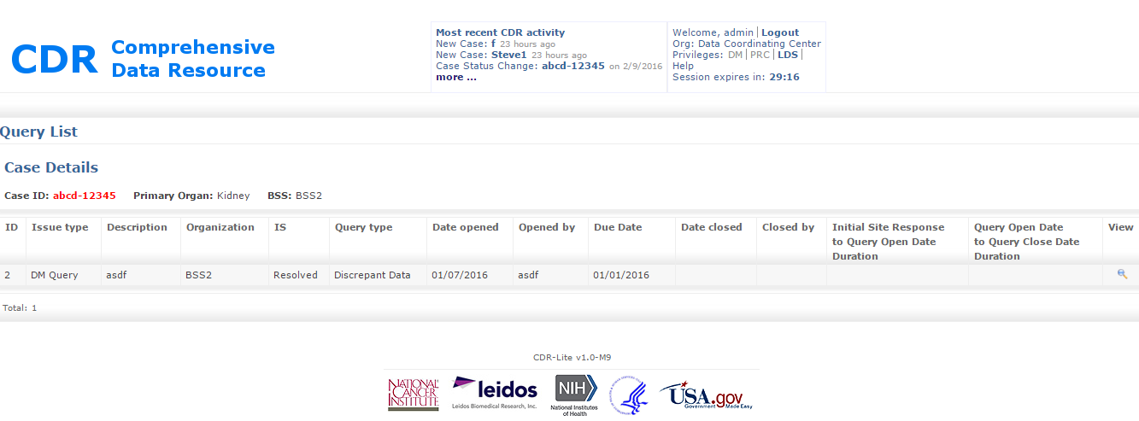

Figure 12 - Query List

### Process

Note: For this example, case Steve1 has one query. In general, the Data Management team generates queries, and the data entry teams (e.g., BSS).respond.

1. Go to the home screen (see Figure 13). Note the Case List has a red 1 for case ID Steve1.

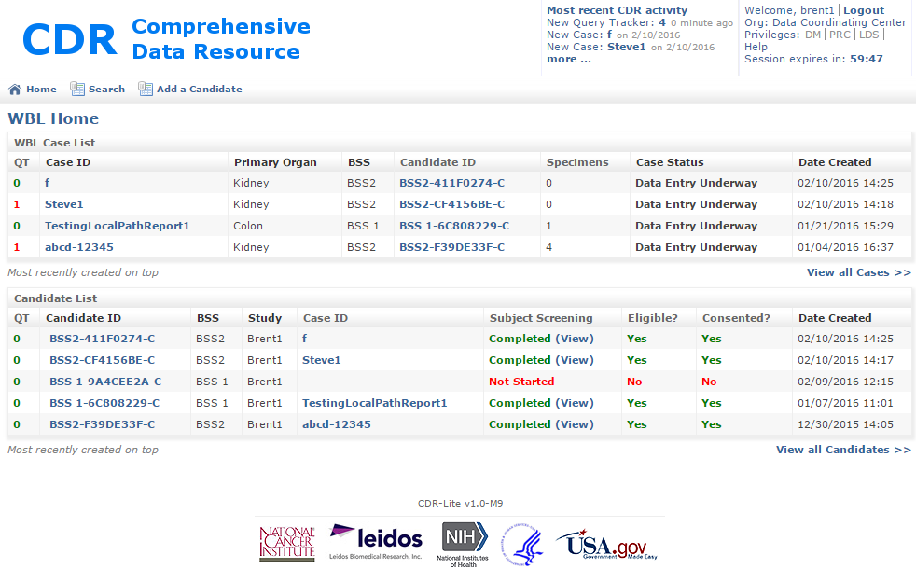

Figure 13- Example Home Screen with Case Steve1 having a Query Pending

1. Click on the red number for the row with case ID Steve1. . This brings up the case-specific Steve1 Query List, with the query details for Steve1, Figure 14
2. The case is no longer editable, but submitted. This brings up the Query List, with the Case Details for Steve1, Figure 14.

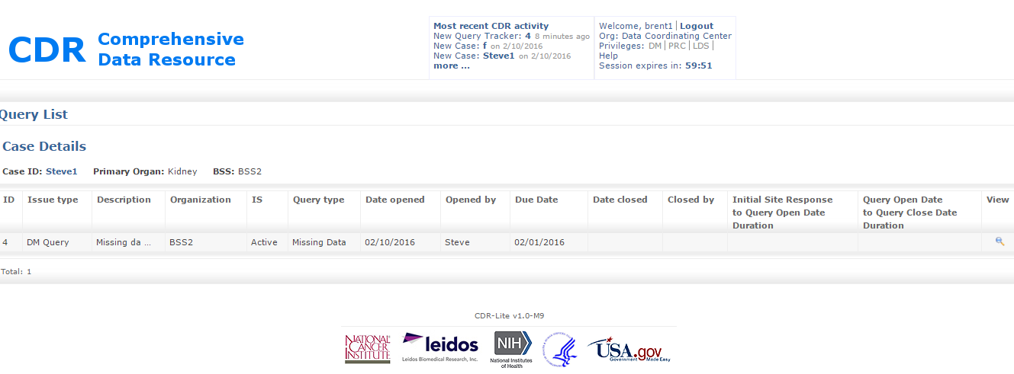

Figure 14 - Query List, with Case Details for the Query on Case Steve1

1. Click on the magnifying glass icon in the View column. This shows the full set of case details.

## Adding a New Candidate

“Candidate” refers to a potential participant in a study. The Candidate becomes associated with a Case once screened, consented, and determined to be eligible. Eligibility criteria are unique to each study and are beyond the scope of this document.

### Process

1. After identifying a candidate for entry into the CDR system, go to the Home Screen, then click **Add New Candidate** (Figure 15).

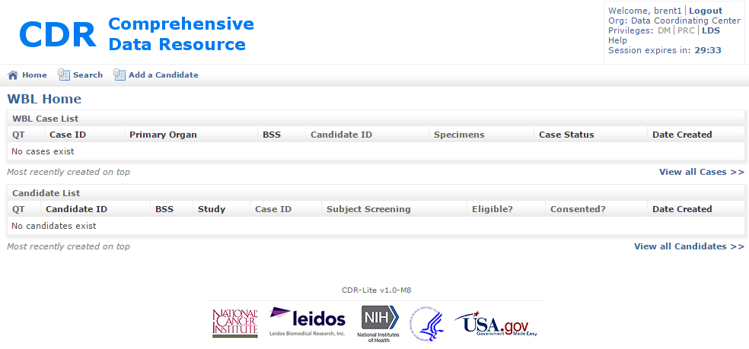

Figure 15 - Adding a Candidate from the Study Home Page

1. The **Create New Candidate Record** form appears as shown in Figure 16.

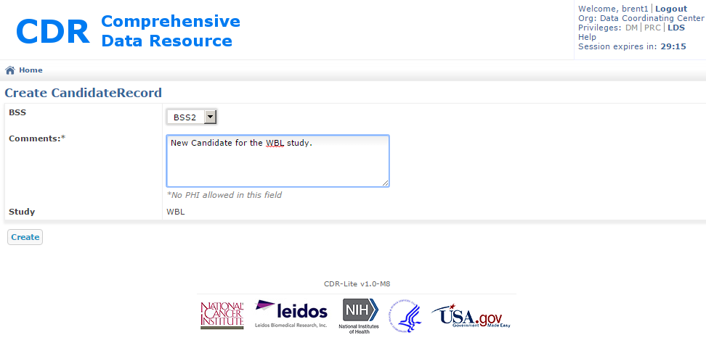

Figure 16 - Create New Candidate Record Form

1. Select the BSS the user represents.
2. The Study field pre-populates with the name of the study.
3. When finished, click **Save**. The screen updates showing the candidate record, as in Figure 17. The following points are important:
4. The candidate has a unique identifier.
5. Both the Screening Enrollment, and Consent Verification fields also show, indicating those forms need successful completion before the Candidate can proceed in the study.

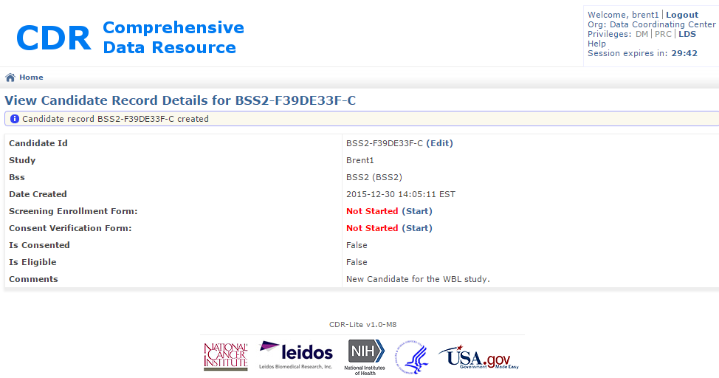

Figure 17 - Example View Candidate Record Details

1. To exit without creating a new Candidate, either use the back arrow on the browser, or click on the Home icon.

Note: a new candidate (one whose record was just created) has not been consented, determined eligible, nor linked to a case.

## Adding a Screening Enrollment Form to a Candidate

The screening enrollment form is for entering general information about the candidate.

### Process

1. After entering information on the candidate, go to the Home Screen, click on the Candidate ID(Figure 18).

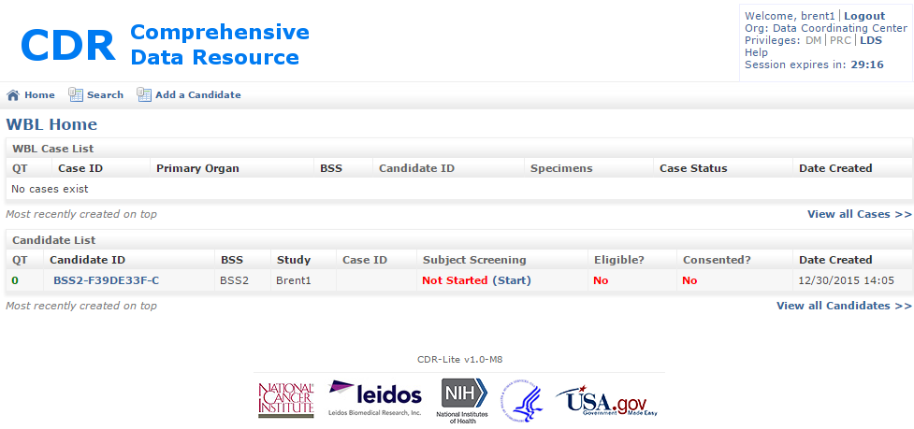

Figure 18 - Study Home Page With One Candidate in List

1. In the Candidate List there is a field titled “Subject Screening”, which has an entry Not Started (Start). Now click on **Start**. This goes to the Candidate Screening form.

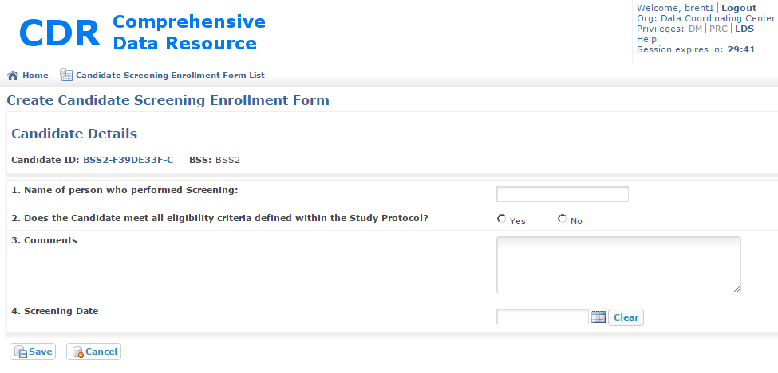

Figure 19 - Create Candidate Screening Enrollment Form

1. Fill out the form:
   1. Name of person who performed the Screening – text field for person
   2. Does the Candidate meet all eligibility criteria defined within the Study Protocol – Click on Yes or No, as appropriate.
   3. Comments – a place for the screener to record any insights they may have.
   4. Screening Date – Calendar select
2. Save the information in the fields by clicking on **Save**. This records the entries, and validates the form. If the form passes automatic validation, the **Submit** button appears (Figure 20).

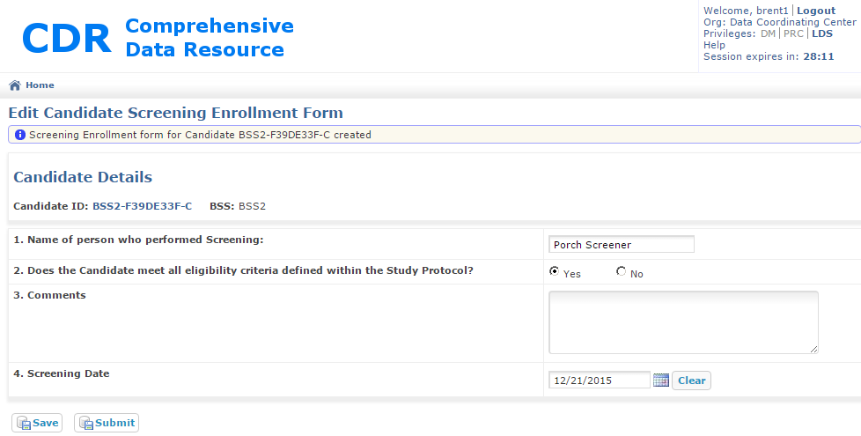

Figure 20 - Example Edit Candidate Screening Enrollment Form

1. If corrections are needed, change the appropriate fields, before clicking on **Save**. Click on Submit once all fields are correct. CDR then goes back to the Candidate Details screen, where the updated status displays (Figure 21).

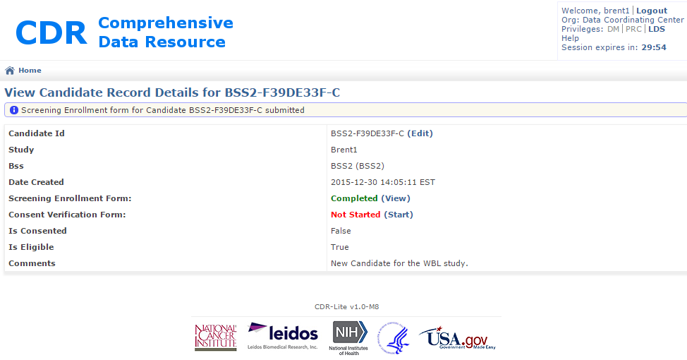

Figure 21 - Updated View Candidate Record Details

1. To Exit without recording the entries, click Cancel, use the browser’s back button, or click on the Home icon.

## Candidate Consent Form

After adding or editing a new candidate, the consent information goes on the Candidate Consent Form. The CDR tracks all candidates regardless of obtaining consent or not. Items 1 through 11 determine eligibility, while the remaining items contain important information that does not affect eligibility. Complete only the top portion before saving the form. Questions 13 and 15 require comments if answered “Yes.”

### Process

1. From the Study Home page, find the candidate to be consented.

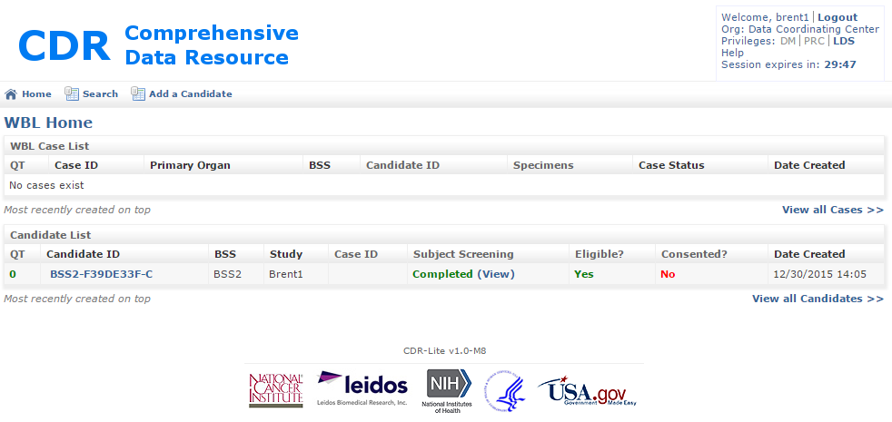

Figure 22 - Study Home Page, Where Candidate Needs Consent Added

1. Click on the Candidate ID. This goes to the Candidate Records Details form (Figure 23).

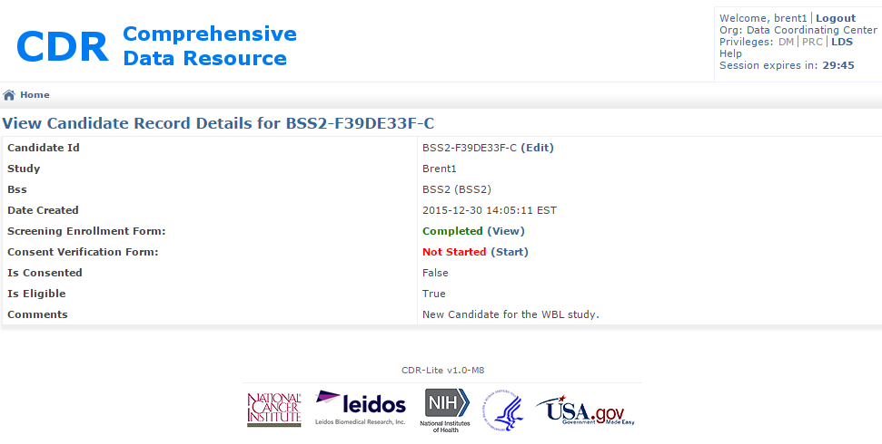

Figure 23 - Candidate Details where Consent Verification Needed

1. In the field labeled Consent Verification Form, click on the highlighted word Start. This goes to the Create Candidate Consent Validation Form (Figure 24) for entering the following fields.
2. Site Protocol Number – Unique identifier given to the protocol at this BSS for the Study
3. Person Obtaining Consent – The person at the BSS obtaining consent
4. Relationship to donor – The consenting person’s relationship to the donor; May be self, spouse, parent, sibling, other (specify)
5. Does the candidate meet all eligibility criteria within the study Protocol – Enter either Yes or No
6. Was Consent Obtained – Enter either Yes or No
7. Institutional version of Informed Consent Document – version of informed consent document in force when consented; This may change during the course of a long study
8. IRB Approval Date – Date that the Institutional Review Board approved the study protocol
9. IRB Expiration Date – Date that the IRB expires.
10. Willingness to be contacted for Other Studies – Enter Yes or No if the candidate agrees
11. Specify Limitations if any – Free text, stating any limits on consent that are stipulated by the participant.
12. Comments – Free Text where the person obtaining consent may make notes (optional)

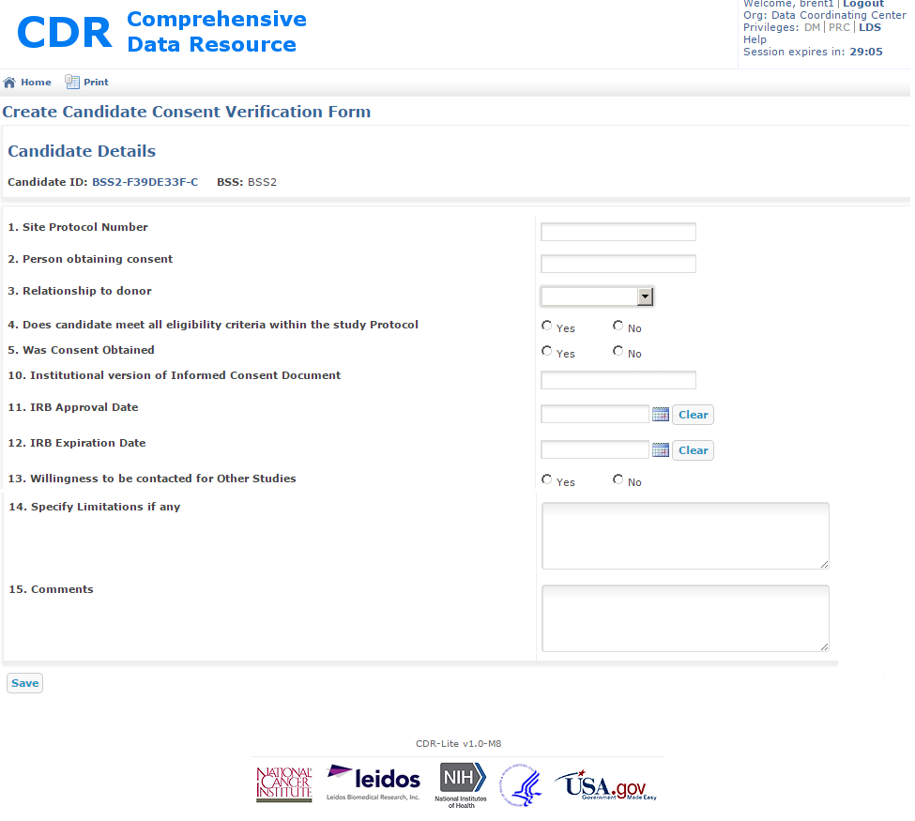

Figure 24 - Create Candidate Consent Validation Form

1. When complete, press the **Save** button.
2. The screen will then show an edit window for the Consent Validation Form. Here the values for the fields should be reviewed, and modified as necessary. (After modification, press **Save** again).

When complete, and accurate, press **Submit**. CDR returns to the Candidate Details screen. If the subject has consented, additional fields become visible.

).

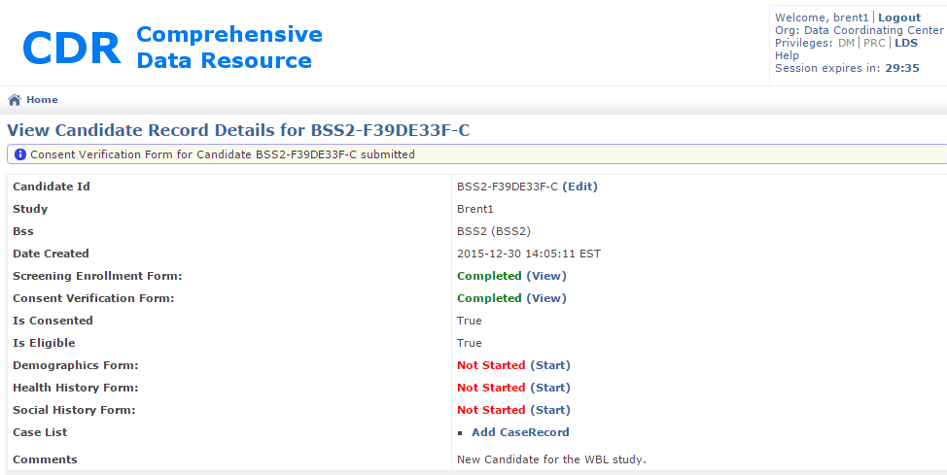

Figure 25 - Expanded View Candidate Record Details Form

## Entering Candidate Demographics Form

The demographics form records basic information about a candidate, such as height, weight, race, and ethnicity. All candidates must be associated with a demographics form. Research has demonstrated that levels of analytes may be affected by a variety of factors such as the overall health of the human research participant, food, and beverages consumed prior to biospecimen collection, the medication status of the patient, and the time of day at which the biospecimen is collected.

### Process

1. Go to the View Candidate Record Details form (Figure 25).
2. Find the item Demographics Form, and click on the word **Start**, in blue. This will take you to the Demographics form screen

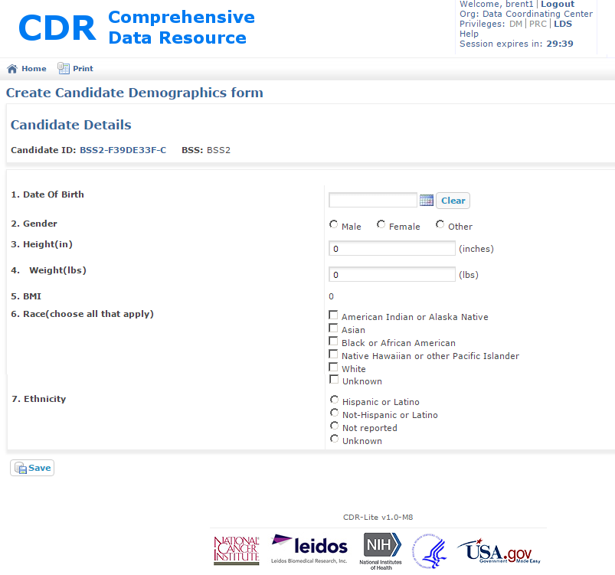

Figure 26 – Create Candidate Demographics Form

1. Enter the data as follows
2. Date of Birth – PII information! Use the calendar tool for selecting the candidate’s birth date.
3. Gender – Select Male, Female, or other, as appropriate. Selecting other brings up a text entry field for specifying the gender information.
4. Height – In inches, how tall the candidate is. Entry must be greater than zero.
5. Weight – In pounds, current weight of the candidate
6. BMI – Auto calculated field. The body-mass index of the candidate
7. Race – This question allows for multiple responses. Select all that apply.
8. Ethnicity – This question allows for multiple responses. Select all that apply.
9. After entering all fields, click the **Save** button. CDR performs automated checks for completeness. Any problems found show in a red box at the top of the screen, and the questions boxed in red.
10. Click on the **Submit** button. This certifies that the data is complete, and ready for Data Management review. The screen shifts back to the View Candidate Record as shown in Figure 18. Please note how the Demographics Form has changed to Completed.



Figure 27 - Expanded View Candidate Record Details

To make changes in the completed Demographics form, click on **View**, which shows the record information, and then click on **Resume Edit**.

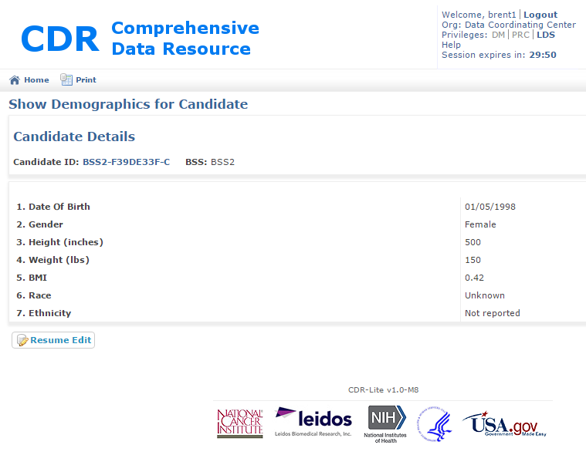

Figure 28 - Show Demographics for Candidate with Resume Edit button

## Entering Candidate Health History Form

Entering health history is a compound process. First, a health history record is created, which only contains the source of the health history, and the cancer history of the candidate. After creating the health history record, create the general medical history records. Finally, add the medications history.

### Process

Creating the Health History Record

1. Go to the View Candidate Record Details form (Figure 25).
2. Find the item Health History Form, and click on the word Start, in blue. This will take you to the Create Health History form

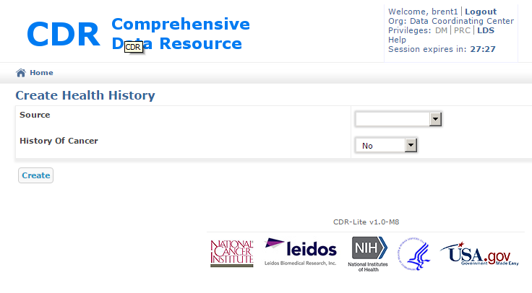

Figure 29 - Create Health History Form

1. Enter the data as follows
2. Source – Pull down menu, indicating the source of health history information. The selections are Self-Report, Medical Record, and Family Report
3. History of Cancer – Has this candidate ever had cancer before? Answers are Yes, No, and Unknown.
4. After answering both questions, click on **Create** for storing the information. If a field was not completed, then an error message shows at the top of the screen, and the missing field has a red line around it.
5. After successfully creating the health history record, the screen goes to Show Health History

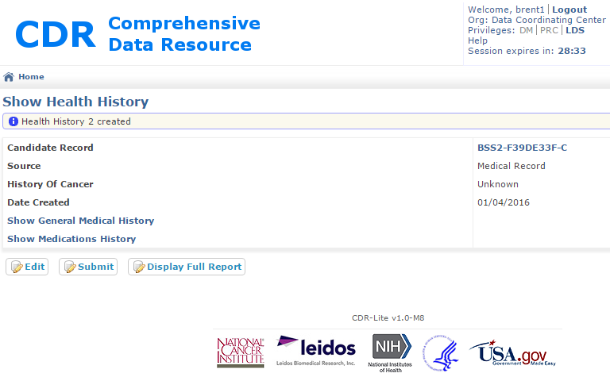

Figure 30 - Show Health History Screen

Adding General Medical History

1. Click on the text in blue, **Show General Medical History**, in the Show Health History screen. This brings up the General Medical History Candidate Details form, shown in Figure 31.

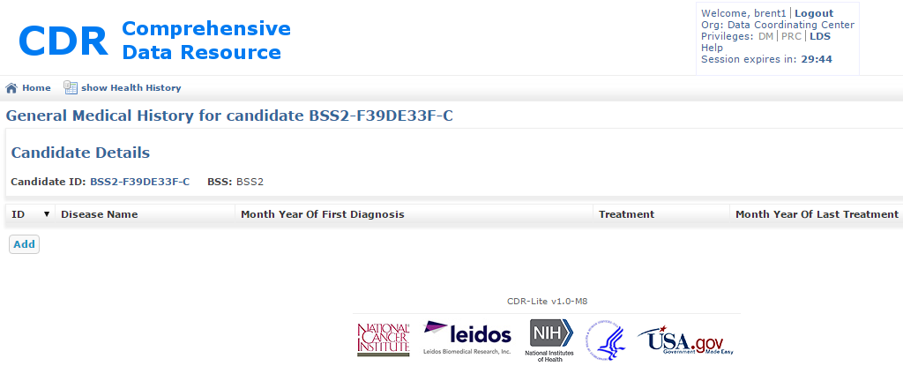

Figure 31 - Form for Entering Health History Details

1. An additional portion of the screen reveals itself for recording an instance of disease history (Figure 32). The fields are:
   1. Disease Name – Name of the individual disease
   2. Month Year of First Diagnosis – Select, from pulldowns, when the diagnosis was made
   3. Treatment - Select one of Yes, No, or Unknown for describing if the disease was treated.
   4. Month Year of Last Treatment – Select, from pulldowns, the date of the last treatment for this disease
   5. Source – The source of this disease history record: Self-Reported, Medical History, or Family Report

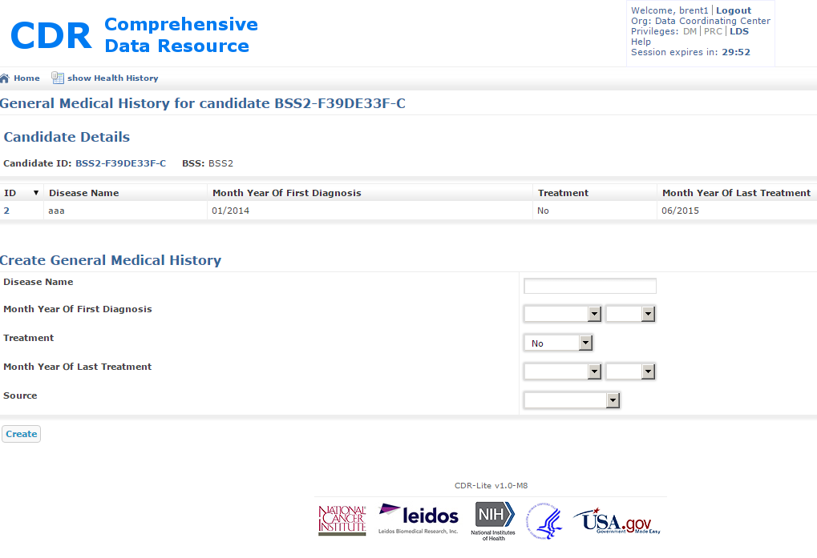

Figure 32 - Create General Medical History Record Fields

1. After entering all fields, press the Create button to store the information
2. Repeat entering all disease history
3. Once all disease history is entered, press the show Health History icon near the top of the display

Adding General Medical History

1. Click on the text in blue, **Show Medications History**, in the Show Health History display. This brings up the Medications History List, as shown in Figure 33.

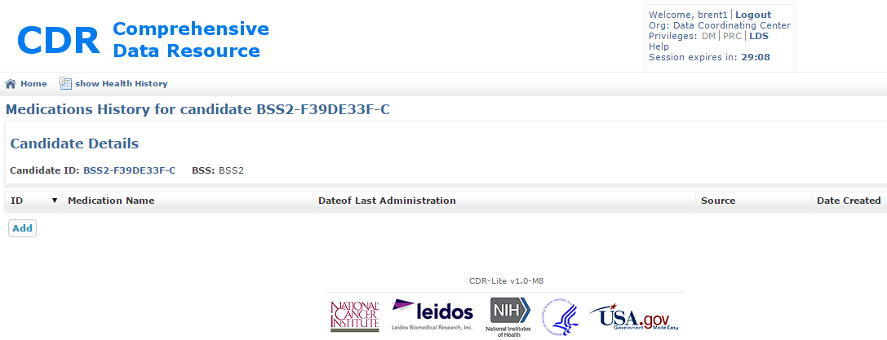

Figure 33 - Medications History List for a Candidate

1. For each medication listed, press the Add button, fill out the fields revealed on the Medications History form, and press **Create**.

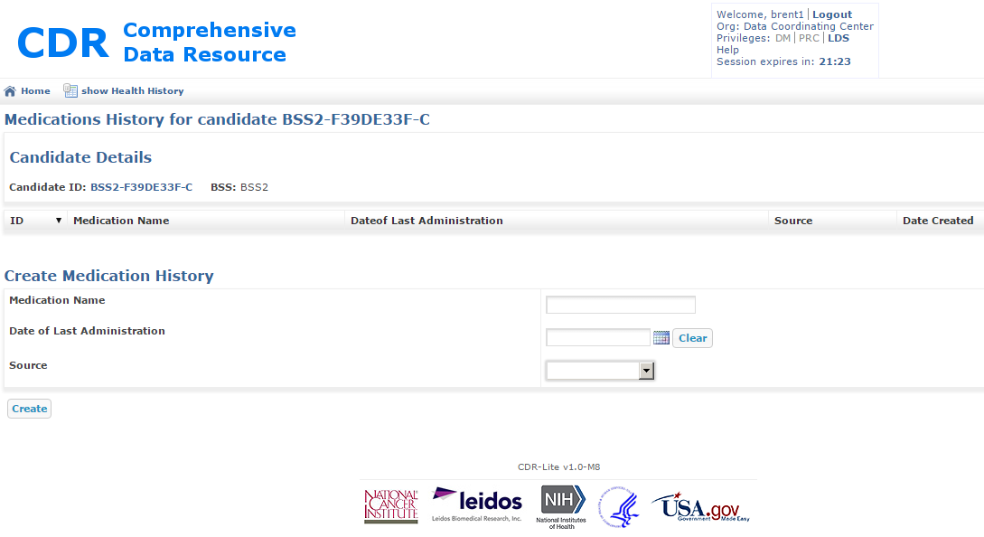

Figure 34 - Additional Fields for Creating an Entry in the Medications History

1. After entering all medications, click on the show Health History icon near the top of the screen. This brings up the Show Health History screen. After entering all medical history, click on the **Submit** button, submitting this information for review. This causes the View Candidate Record Details screen. If the submission was successful, a note displays under the window title.

## Entering Candidate Social History Form

The social history form records information about smoking and alcohol exposure.

### Process

1. On the View Candidate Record Details screen, find the line Social History Form, and click on the word in blue, **Start**.
2. This brings up the Create Social History screen, for a particular candidate, shown in Figure 35.

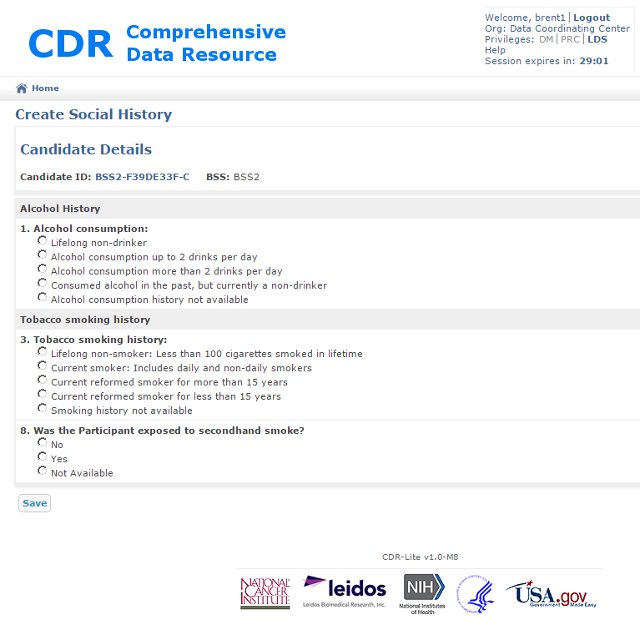

Figure 35 – Create Social History Screen

1. Each item here only allows a single response to each question. Answer each question, and then press the Save button. CDR will confirm that all questions have a response. If satisfactory, the **Save** button at the bottom is replaced by two buttons **Update** and **Submit**. If the information needs changing, alter the values and press Update. If the information is complete, press Submit.
2. CDR goes to the View Candidate Record Details screen.

## Adding Candidate Case Records

When found eligible, a candidate may be accepted into a study. At acceptance, the candidate becomes associated with a case. The breadth of the case includes all information detailing around tissue collection, processing, and storage.

### Process

1. On the View Candidate Record Details Screen, Figure 17, find the Case List item. Click on the text in blue, to the right, Add Case Record. CDR goes to the Create Case Record Screen, Figure 36.

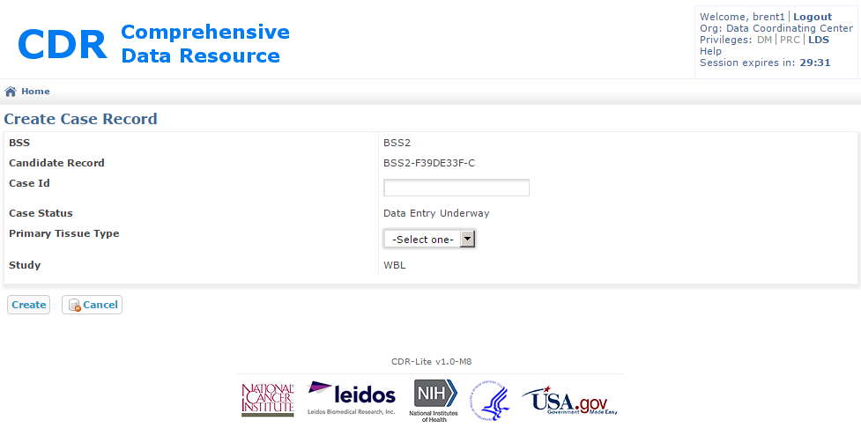

Figure 36 - Creating a Case Record for a Candidate

1. Enter the fields as follows:
   1. Case ID – Unique identifier given to this case
   2. Case Status – Automatically Generated as Data Entry Underway, and updatable with the Case Record Detail screen, Figure 37
   3. Primary Tissue Type – Select one from the list of tissues involved in this study
   4. Study – Automatically displayed reminder of the name of the current study
2. Click on the **Create** button. CDR goes to the Show Case Record Details for the case number just entered. A note shows under the title, when the case successfully records.

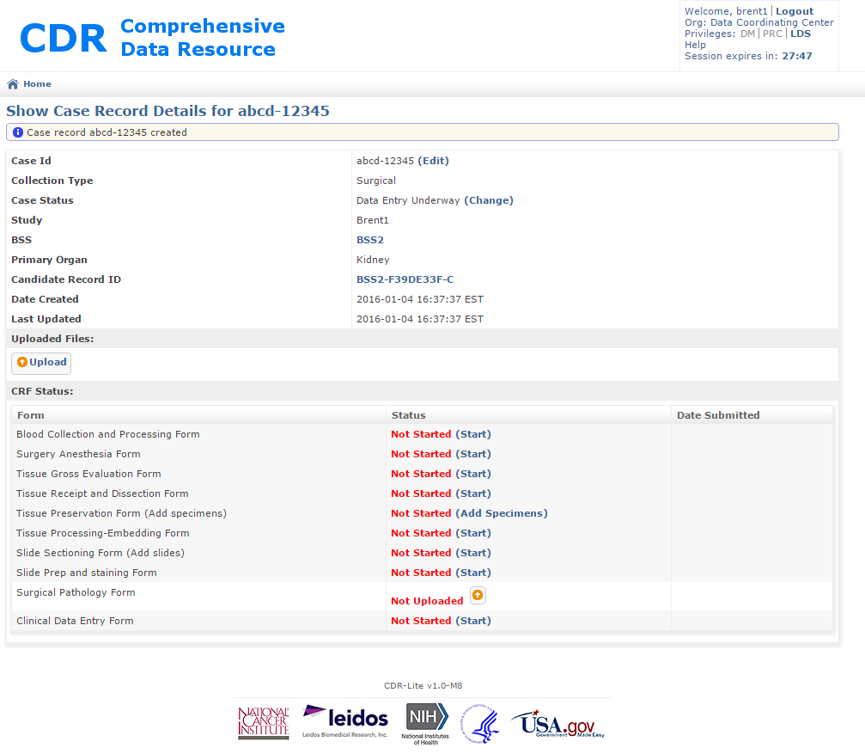

Figure 37 - Show Case Record Details screen

1. By clicking on the blue text **(Change)** in the Case Status line, CDR brings up a Change Case Status page, Figure 38. Select the new status of the case from the pull-down menu, and click “Update.” CDR returns to the update Show Case Record Details page. A typical progression of Case Status values is in Figure 3.

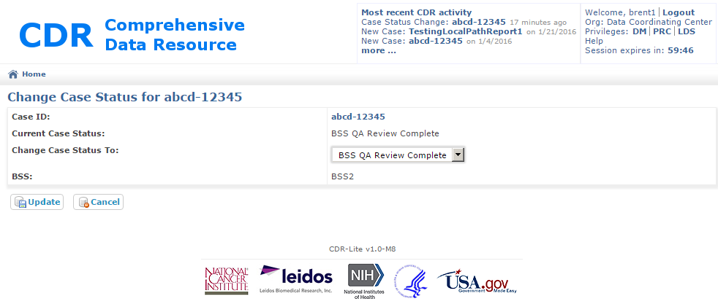

Figure 38 - Change Case Status Screen

1. The BSS user must enter each form in the CRF Status. Sections 3.15 through 3.24 describe these forms, and describe the fields.

## Adding a Blood Collection and Processing Form

The Blood Form provides access to information on each blood draw. Separate blood draw forms cover the details of each blood draw.

### Process

1. On the Show Case Record Details Screen, Figure 37, find the Blood Collection and Processing Form. Click on the text in blue, to the right, **Start.** CDR goes to the Edit Blood Form, Figure 39.

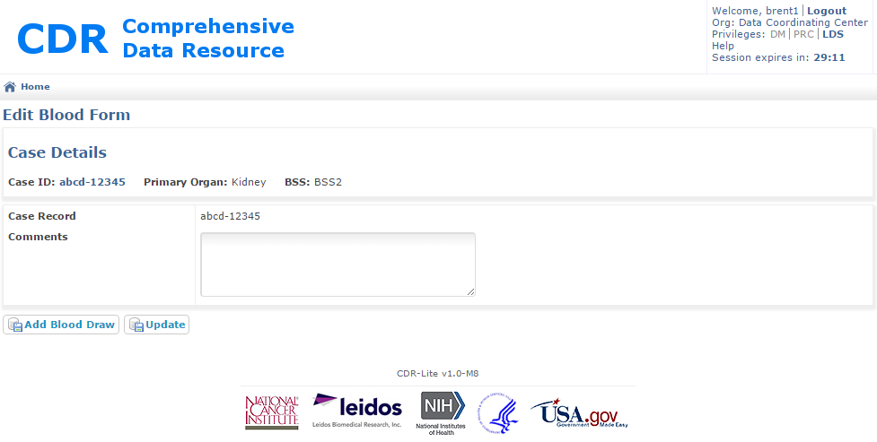

Figure 39 - Editing a Blood Form

1. The following information fills automatically from information previously entered:

Case ID - Unique ID given to the case associated with this blood form. Clicking the text in blue navigates CDR to the Show Case Record Details Screen, Figure 37.

Primary Organ - Organ in the study associated with this case.

BSS – The biospecimen source site associated with this collection.

1. Enter the one optional field as follows:
   1. Comment – Any free text necessary for describing across all draws.
2. Click on the **Add Blood Draw** button. CDR goes to the Edit Blood Draw form, recording details of each draw. Because of the large number of fields in this form, Figure 40 shows a slightly scaled version of the entire form.

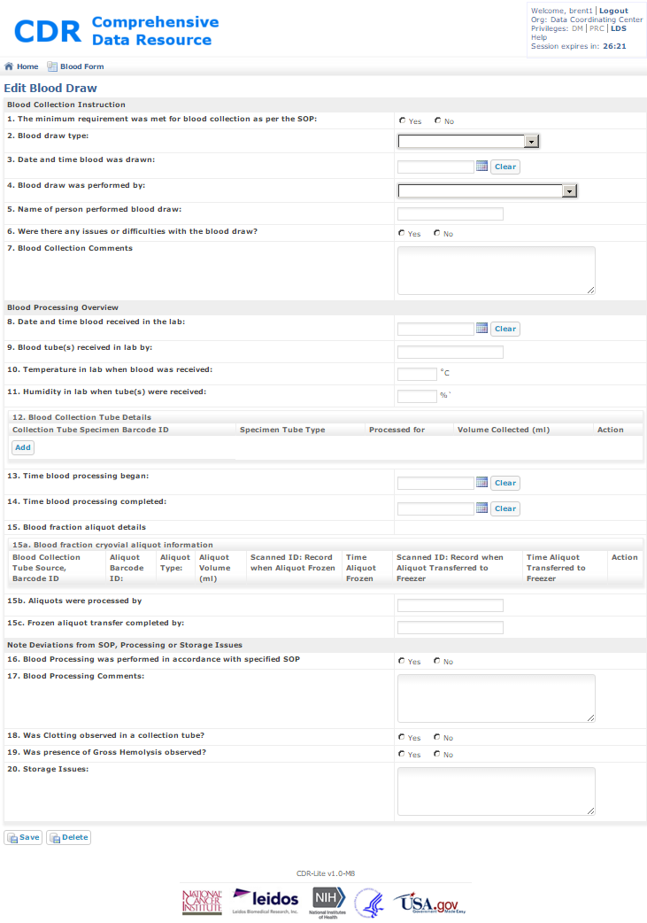

Figure 40 - Edit Blood Draw Screen

1. Enter the fields as follows:
   1. Minimum Requirement was met for blood collection as per the SOP: – Required yes or no The exact volume varies between studies and specified in the study specific SOP for this draw.
   2. Blood Draw Type: - Select from “Pre-operative” or “post-operative”, controlled by BloodDrawType list in the vocabulary.
   3. Date and time blood was drawn: - Date /time select by clicking on the calendar icon.
   4. Blood draw was performed by: - Pull down menu of the role for the individual performing the sampling.
   5. Name of person performed blood draw: - Free text field giving the name of the individual performing the sampling.
   6. Were there any issues or difficulties with the blood draw? – Required yes or no
   7. Blood Collection Comments – Free text describing anything specific about this individual draw.
   8. Date and time blood received in the lab: - - Date /time select by clicking on the calendar icon.
   9. Blood tube(s) received in lab by: - Free text field giving the name of the person receiving the tubes.
   10. Temperature in lab when blood was received: - Ambient air temperature in the room where the lab is located
   11. Humidity in lab when tube(s) were received: - Ambient air relative humidity in the room where the lab is located
   12. Blood Collection Tube Details: - For each tube in the collection, add a line. By clicking on the **Add** button, a sub-screen displays for entering the following for all tubes used.  
       Collection Tube Specimen Barcode ID: - Unique barcode on the collection tube used for the collection  
       Specimen Tube Type: - Selection from a list of potential collection tube types. List controlled by “BloodTubeType List” in Vocabulary.  
       Processed for: - Selection from a list of potential targets, such as DNA, RNA, and Plasma. List controlled by “BloodCollectionReason List” in Vocabulary.  
       Volume Collected: - Number of milliliters of product collected in this tube.  
       When all tubes are entered, click on the Save button.
   13. Time blood processing began: - Date /time select by clicking on the calendar icon.
   14. Time blood processing completed: - Date /time select by clicking on the calendar icon.
   15. a. Blood Fraction cryovial aliquot information  
       Clicking on the Add button, after entering tubes for question 12, opens a sub-screen for recording additional information about frozen specimens:  
       Blood Collection Tube Source, Barcode ID – prepopulated pull down selection of tube IDs  
       Aliquot Barcode ID: - ID associated with a single portion of the sample.  
       Aliquot Type: - Pull down menu with blood product types.  
       Aliquot Volume (ml) – volume of this particular part of the overall sample  
       Scanned ID: Record when Aliquot Frozen: - Record of tube ID at time of freezing  
       Scanned ID: Record when Aliquot Transferred to Freezer: - Record of tube ID at time of transfer to freezer storage  
       Time Aliquot Transferred to Freezer: - Time of material transfer to freezer storage
2. Aliquots were processed by: - Name of individual performing the processing.
3. Frozen aliquot transfer completed by: - Name of individual moving the aliquots to the freezer storage
   1. Blood Processing was performed in accordance with specified SOP: - Required yes or no
   2. Blood Processing Comments: - Free text describing any notes specific to processing
   3. Was Clotting observed in a collection tube? - Required yes or no
   4. Was presence of Gross Hemolysis observed? - Required yes or no
   5. Storage Issues: Free text describing any problems or incidents in storage
4. Once completed, click on the **Save** button. Any problems display a description of the faults at the top of the screen.
5. When all problem are resolved, pressing the Save button, a message is displayed at the top of the form stating “Draw ## Updated”.
6. To enter additional draws, click on the Blood Form icon near the top of the form, and repeat the process.

## Adding a Surgery Anesthesia Form

The surgery-anesthesia form records pre-analytic variable information about the collection event. This information is critical in understanding the context of the tissue collection.

### Process

1. On the Show Case Record Detail screen, Figure 33, find the Surgery Anesthesia Form. Click on the text in blue, to the right, **Start**. The CDR goes to the Create Surgery Anesthesia Form screen, shown in Figure 41.
2. The following information fills automatically from information previously entered:

Case ID - Unique ID given to the case associated with this blood form. Clicking the text in blue navigates CDR to the Show Case Record Details Screen, Figure 37.

Primary Organ - Organ in the study associated with this case.

BSS – The biospecimen source site associated with this collection.

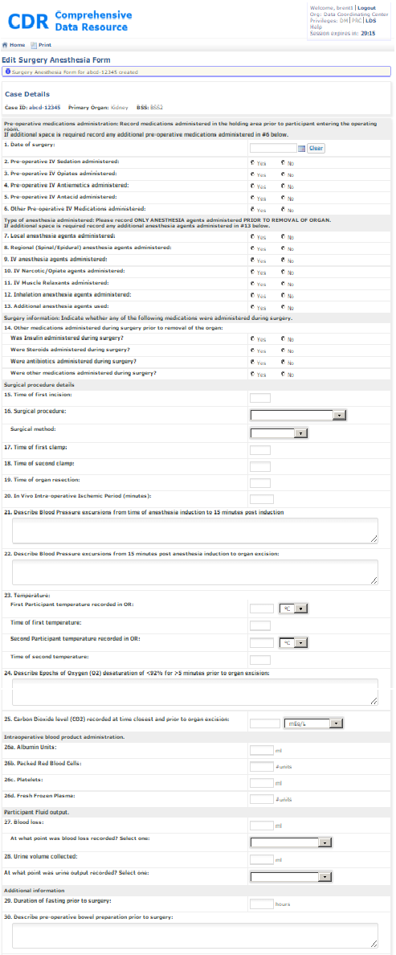

Figure 41 – Surgery Anesthisia Form

1. Enter the fields as follows:
   1. Date of Surgery – Calendar select tool for specifying the date the biospecimens were collected
   2. Pre-operative IV Sedation administered: – Required Yes or No
   3. Pre-operative IV Opiates administered: - Required Yes or No
   4. Pre-operative IV Antiemetics administered: - Required Yes or No
   5. Other pre-operative IV Medications administered: - Required Yes or No
   6. Pre-operative IV Antiemetics administered: - Required Yes or No
   7. Local anesthesia agents administered: - Required Yes or No
   8. Regional (Spinal/Epidural) anesthesia agents administered: - Required Yes or No
   9. IV anesthesia agents administered: - Required Yes or No
   10. IV Narcotic/Opiate agents administered: - Required Yes or No
   11. IV Muscle Relaxants administered: - Required Yes or N
   12. Inhalation anesthesia agents administered: - Required Yes or No
   13. Additional anesthesia agents used: - Required Yes or No
   14. Other Medications administered during surgery prior to removal of the organ:   
       Was Insulin administered during surgery: - Required Yes or No  
       Were Steroids administered during surgery: - Required Yes or No  
       Were antibiotics administered during surgery – Required Yes or No.  
       Were there medications administered during surgery: - Required Yes or No
   15. Time of first incision: - Enter Hour and Minute , on a 24 hour clock
   16. Surgical procedure: - Required drop down list of applicable surgical procedures.  
       Surgical method: - Required drop down list of standard methodologies. If not in the list, select “Other,” and a text box shows, allowing for recording the specific methodology.
   17. Time of first clamp: - Required hour and minute of the time blood flow is restricted to the organ.
   18. Time of second clamp: - Required hour and minute of the time second blood restricted to the organ.
   19. Time of resection: - Required hour and minute of the organ resection
   20. In Vivo Intra-operative Ischemic Period (minutes); - Required duration, in minutes,
   21. Describe Blood Pressure excursions from time of anesthesia induction to 15 minutes post induction: - Free text comment on blood pressure observations.
   22. Describe Blood Pressure excursions from 15 minutes post induction to organ excision: - Free text comment on blood pressure observations.
   23. Temperature:  
       First Participant temperature recorded in OR: - Mandatory body temperature in Census.   
       Were steroids administered during surgery – Required Yes or No  
       Were antibiotics administered during surgery – Required Yes or No  
       Were there medications administered during surgery – Required Yes or No
   24. Describe Epochs of Oxygen (O2) desaturation of <92% for >5 minutes prior to organ excision: - Free text field for making note of any O2 desaturations
   25. Carbon Dioxide level (CO2) recorded at time closest and prior to organ excision: - the measure and units of CO2 recorded in the patient during surgery
   26. Intraoperative blood product administration:  
       a. Albumin Units: - Milliliters of albumin administered during the procedure.   
       b. Packed Red Blood Cells – Units of packed red blood cells administered during the procedure.   
       c. Platelets– milliliters of platelets administered during the procedure.   
       d. Fresh Frozen Plasma– Units of fresh frozen plasma administered during the procedure.
   27. Blood loss: - Number of milliliters of blood lost by the patient during the procedure  
       At what point was blood loss recorded? Select one: - Pull down menu of epochs in the procedure when the patients’ blood was lost.
   28. Urine Volume Collected: - Number of milliliters of urine collected by the patient during the procedure.  
       At what point was urine output recorded? Select one: - Pull down menu of epochs in the procedure when the patients urine was recorded
   29. Duration of fasting prior to surgery: - In Hours, how long has the patient gone without food
   30. Describe pre-operative bowel preparation prior to surgery:– Free text description of bowel preparation, if any
   31. Other notable events during surgery: – Free text describing any noteworthy events during surgery, if any.
   32. Time Specimen left OR: - Required hour, and minute, the collected tissue was removed from the OR, typically to go to Pathology.
2. Now click on the **Save** button. If successfully added, then a note shows under the title. Otherwise, error messages display in red.
3. Click on **Home** to go back to the Study Home page.

## Adding a Tissue Gross Evaluation Form

The BSS local pathology lab provides the gross evaluation of the biospecimens’ collection. This includes immediate and interim processing.

### Process

1. On the View Candidate Record Details Screen, Figure 17, find the Tissue Gross Evaluation Form item. Click on the text in blue, to the right, **Start**. CDR goes to the Create Tissue Gross Evaluation screen, Figure 42.

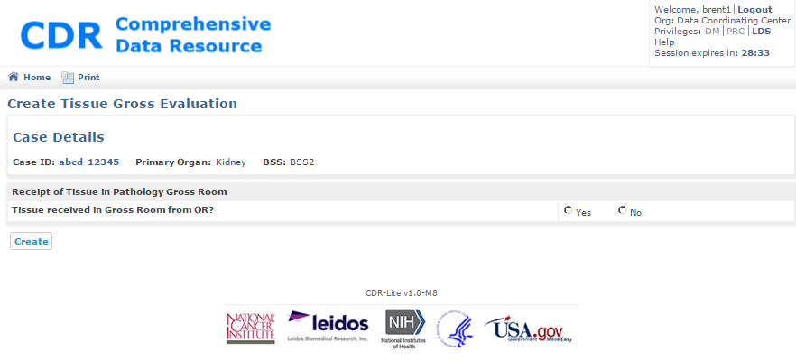

Figure 42 - Create Tissue Gross Evaluation Screen

1. Under the Case Details line, the following specific information displays:
   1. Case ID – Unique identifier given to this case; Clicking on this takes CDR to the Display Case screen
   2. Primary Organ – Name of organ under evaluation
   3. BSS – Name of the biospecimen source site procuring this tissue
2. There is only one field on this screen. Enter this field as follows:
3. Tissue received in Gross Room from OR? - Mandatory yes or no question
4. If the Tissue was received in the Gross Room, then the Create Tissue Gross Evaluation form is expanded to Figure 43, where the following fields are available:
   1. Date and time Specimen arrived in pathology gross room from OR: - Required selection from calendar tool.
   2. Specimen was received in gross room by: - Required free text of person’s name receiving the tissue in the Pathology Gross Room.
   3. SOP governing transport of tissue from OR to pathology gross room: - Mandatory ID of the SOP governing tissue handling during transport.
   4. Transport of tissue was performed per Surgical Tissue Collection and Preservation SOP: -Mandatory Yes or No about following study-specific SOP. If No is selected, a mandatory free text comment field shows for entering the notes.
   5. Temperature of pathology gross room when specimen arrived from OR: - Air temperature, in degrees centigrade, in the Pathology Gross Room.
   6. Humidity of pathology gross room when specimen arrived from OR: - Relative humidity in the Pathology Gross Room.
   7. Gross evaluation of resected tissue was performed by: - Mandatory free text entry of the name of the pathologist performing the gross evaluation.
   8. Dimensions of resection: - Size, in three dimensions, of the tissue sample.
   9. Weight of resection: - Mass, in grams, of the tissue specimen.
   10. Gross appearance of disease was observed in resected tissue: - Mandatory Yes or No.
   11. Comments: - Free text description of overall gross appearance of tissue.
   12. Gross diagnosis of resected tissue: - Required high level text evaluating the tissue.
   13. Photograph(s) of tissue was/were taken in pathology gross room? – Mandatory Yes or No; if "Yes” is selected, then there is an option to upload the files with the tissue photographs.
   14. Pathology ink used? – Mandatory Yes or No; if "Yes" is selected, a free text field is shown for specifying the type of ink used.
   15. Tumor tissue was released to the tissue bank? - Mandatory Yes or No; if the answer is “Yes”, then fill the additional fields shown in Figure 44.

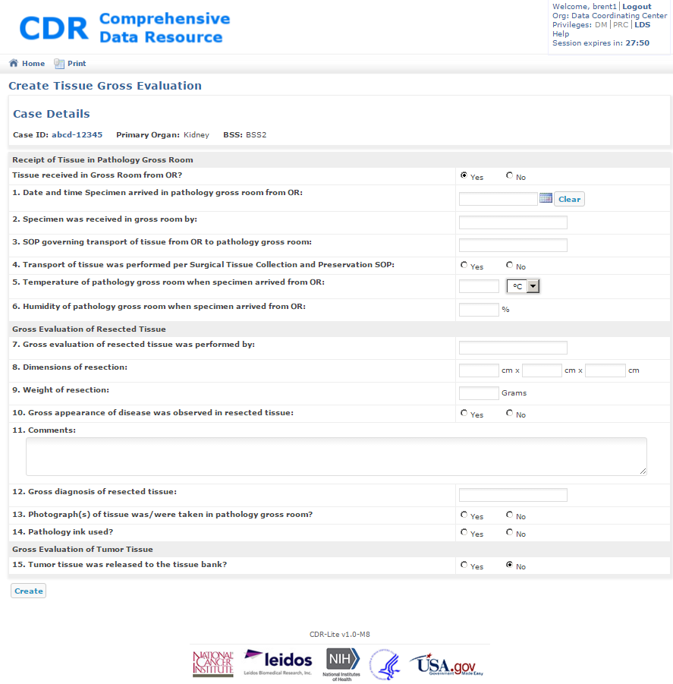

Figure 43 - Expanded Create Tissue Gross Evaluation Form

* 1. Tissue Bank ID: - Required. Identification of the tissue bank storing the tissue
  2. Dimensions of tissue: - Required: Size of the tumor tissue in centimeters
  3. Percentage of gross area of necrosis of material sent to tissue bank: - Required: The percentage of tissue area showing necrosis
  4. Percentage of tumor content of material sent to tissue bank: - Required: the percentage of the “tumor” tissue containing actual tumor material
  5. Gross appearance of material sent to tissue bank: - Free text commentary on the transported material
  6. Do the dimensions of each experimental piece meet the criteria specified within the Surgical Tissue Collection and Preservation SOP? - Mandatory Yes or No; if no, then a text field is exposed for storing notes on why the experimental piece did not meet the criteria
  7. Normal adjacent tissue was released to the tissue bank in addition to tumor tissue? – Mandatory Yes or No
  8. If the answer to 22 is "Yes", then an additional set of fields show for gathering the normal adjacent tissue size, in cm.
  9. Time specimen was transferred from the pathology gross room to the tissue bank: - Time, in 24-hour clock values, that the material was transferred to the tissue bank.

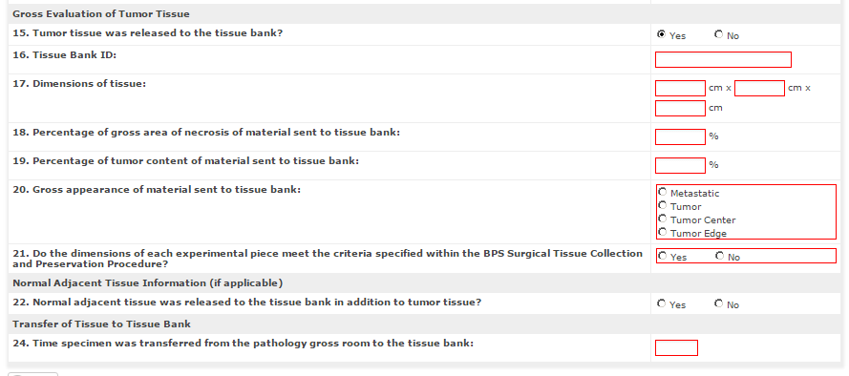

Figure 44 - Additional Tissue Gross Evaluation Fields for Tissue Bank

1. Now click on **Create**, or **Save**. If the tissue was not received in the Pathology Gross Room, then an explanation must be entered before pressing **Save**.

## Adding a Tissue Receipt and Dissection Form

Well-characterized and validated assays are important to all research. Assays need thorough documentation ensuring they are reproducible over time.

### Process

On the View Candidate Record Details Screen, Figure 17, find the Tissue Receipt and Dissection Form item. Click on the text in blue, to the right, **Start**. CDR goes to the Create Tissue Receipt and Dissection screen.

1. Go to the Create Tissue Receipt and Dissection screen, Figure 45.
2. The following information fills automatically from information previously entered:

Case ID - Unique ID given to the case associated with this blood form. Clicking the text in blue navigates CDR to the Show Case Record Details Screen, Figure 37

Primary Organ - Organ in the study associated with this case

BSS – The biospecimen source site associated with this collection

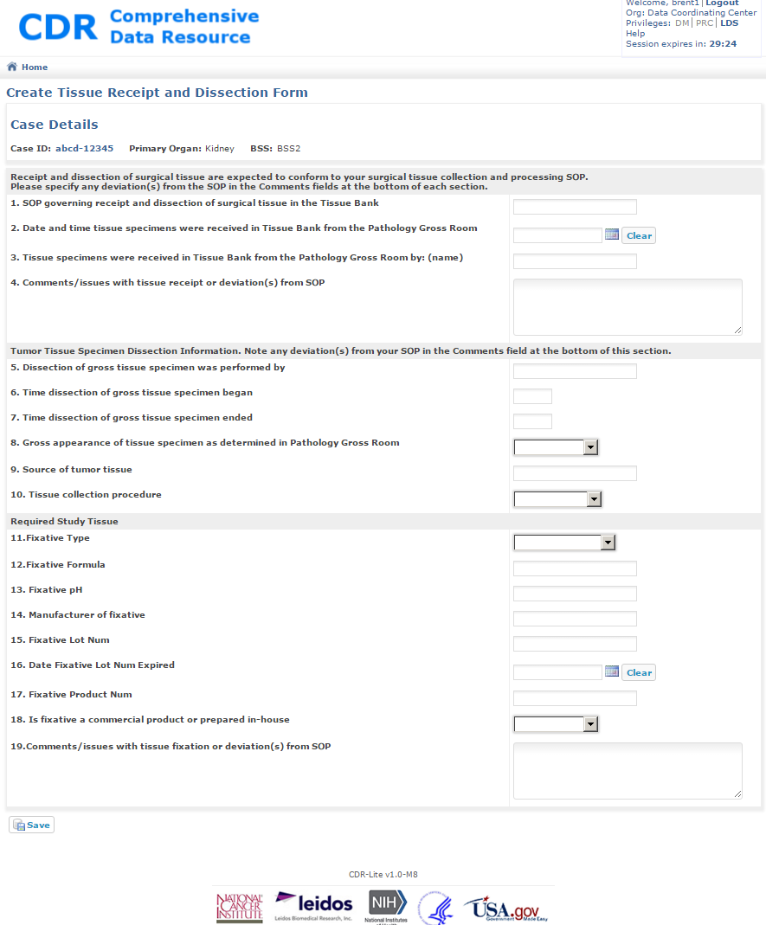

Figure 45 - Creating a Tissue Receipt and Dissection

1. Enter the fields as follows:
   1. SOP Governing receipt and dissection of surgical tissue in the Tissue Bank: - Unique identifier for the SOP in effect when processing this tissue
   2. Date and Time tissue specimens were received in Tissue Bank from the Pathology Gross Room: - Required selection from calendar tool
   3. Tissue specimens were received in Tissue Bank from the Pathology Gross Room by: (name):– Name of individual receiving tissue at the Tissue Bank
   4. Comments/issues with tissue receipt or deviation(s) from SOP: – Free text describing any notes about the tissue upon receipt
   5. Dissection of gross tissue specimen was performed by: - Name of individual actually performing the dissection
   6. Time dissection of gross tissue specimen began: - Required hour and minute (24-hour clock) of the time the dissection began.
   7. Time dissection of gross tissue specimen ended: - Required hour and minute (24-hour clock) of the time the dissection was complete
   8. Gross appearance of tissue specimen as determined in Pathology Gross Room: - Pull down menu, specifying if the tissue was tumor or other. If “Other” selected, then a free text field shows for describing the gross tissue appearance
   9. Source of tumor tissue: - Description of where the tissue was located: primary, metastatic
   10. Tissue collection procedure: - Pull down menu, with selections for surgical, core biopsy, needle biopsy, or “Other”. If selecting “Other”, a free text field shows for describing the procedure used
   11. Fixative Type: - Pull down menu, with selections for buffered-formalin, ethanol, PAXgene tissue, or “Other” – specify. If selecting “Other”, a free text field shows for describing the type of fixative type. List controlled by “Fixative” list in Vocabulary
   12. Fixative Formula: - Free text field for describing the buffer for the fixative
   13. Fixative pH: - Free text field for describing the Ph for the fixative
   14. Manufacturer of fixative: - Free text field for recording the manufacturer of the fixative
   15. Fixative Lot Num: - Free text field for describing the manufacturer’s lot number for the fixative
   16. Date Fixative Lot Num Expired: - Required selection from calendar tool
   17. Fixative Product Num: - Free text field for recording the product number of the fixative
   18. Is fixative a commercial product or prepared in-house: - Pull down menu, with selections for Commercial, In-House, or “Other”. If selected “Other”, a free text field shows for describing the type of fixative preparation
   19. Comments/issues with tissue fixation or deviation(s) from SOP: - Free text field for recording comments, such as any deviations from the SOP
2. Now click on the **Save** button. CDR goes to the Show Case Record Details for the case number just entered. If the form created successfully, then a note shows under the title.

## Adding a Tissue Preservation Form, a.k.a., Adding Specimens

Every attempt at optimizing the handling of biospecimens should minimize molecular changes that can result from processing activities. This includes not only the temperature and timing of biospecimen processing but also such considerations as the size and volume of the biospecimen that will be stored for future use.

### Process

1. On the View Candidate Record Details Screen, Figure 17, find the Case List item. Click on the text in blue, to the right, **Add Case Record**. CDR goes to the Create Case Record Screen, Figure 36.
2. The following information fills automatically from information previously entered:

Case ID - Unique ID given to the case associated with this blood form. Clicking the text in blue navigates CDR to the Show Case Record Details Screen, Figure 37.

Primary Organ - Organ in the study associated with this case.

BSS – The biospecimen source site associated with this collection.

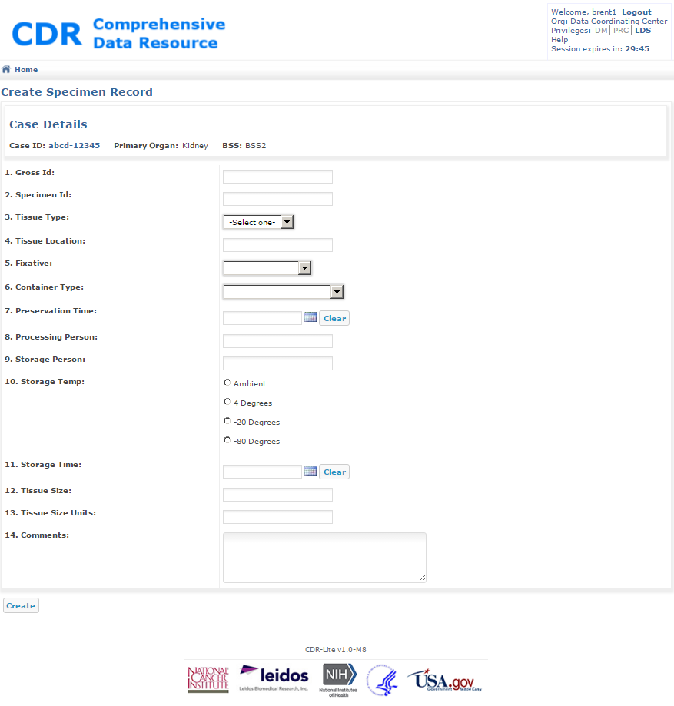

Figure 46 – Creating/Adding Specimens Form

1. Enter the fields as follows:
   1. Gross Id: – ID of the gross specimen from which this aliquot was taken
   2. Specimen Id:– Unique identifier for this particular specimen
   3. Tissue Type:– Select one from the list of tissues involved in this study
   4. Tissue Location: – Free text describing the location of the specimen (e.g., left, right, middle…). List controlled by the “Tissue Type” item in Vocabulary
   5. Fixative: – Select one from the list of fixatives involved in this study. List controlled by “Fixative” list in Vocabulary
   6. Container Type: - Select one from the list of containers involved in this study; List controlled by “Container Type” list in Vocabulary
   7. Preservation Time: – Calendar selection, for entering the date and time preservation began
   8. Processing Person: – Name of individual performing the processing
   9. Storage Person: - Name of individual placing the specimen in storage
   10. Storage Temp: – Select one of the available items, showing the ambient temperature in the specimen storage
   11. Storage Time: - Calendar selection, for entering the date and time the specimen began storage
   12. Tissue Size:– Free text field for entering specimen sizing
   13. Tissue Size Units: - Free text field for entering the units (cm, ml, etc.) used in the specimen sizing
   14. Comments: - Used for recording any observations about the specimen, preservation, or storage
2. Click on the **Create** button. CDR does a first check on the entries. If a problem is found, an error message shows in red at the top of the screen. After making the correction, click on **Save** at the bottom of the form. When there are no problems found, click on the Submit button, which signals the data management team that this record is ready for review. After clicking Submit, the CDR goes to the Show Case Record Details for this record screen.

## Adding a Tissue Processing-Embedding Form

SOPs dictate handling of individual types of biospecimens specific to the biospecimen type and the biomolecules under analysis. This form records the handling of tissues during processing, and embedding, as appropriate to the study.

### Process

1. On the View Candidate Record Details Screen, Figure 17, find the Tissue Processing-Embedding Form item. Click on the text in blue, to the right, **Start**. CDR goes to the Save Tissue Processing-Embedding Form for this case, Figure 47.
2. The following information fills automatically from information previously entered:

Case ID - Unique ID given to the case associated with this blood form. Clicking the text in blue navigates CDR to the Show Case Record Details Screen, Figure 37.

Primary Organ - Organ in the study associated with this case

BSS – The biospecimen source site associated with this collection

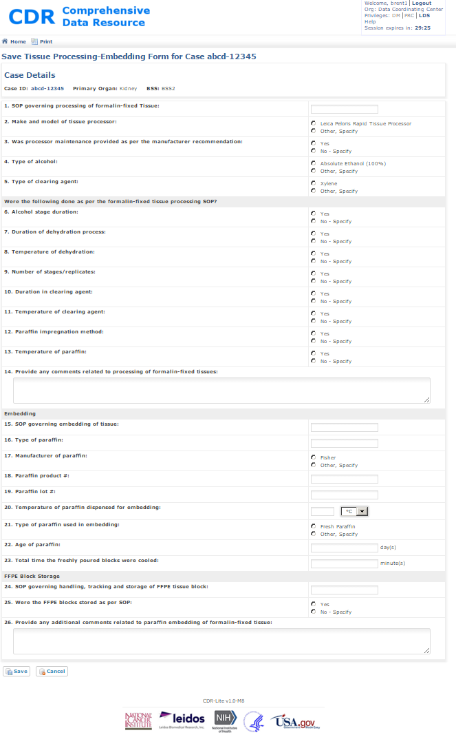

Figure 47 - Creating Save Tissue Processing-Embedding Form for a Case

1. Enter the fields as follows:
   1. SOP governing processing of formalin-fixed Tissue: – Unique identifier given to the SOP governing the processing and embedding of formalin fixed, paraffin embedded tissue.
   2. Make and model of tissue processor: – Single select list of approved processors, and “Other”. Selecting “Other” shows a Specify text box for entering the make and model.
   3. Was processor maintenance provided as per the manufacturer recommendation: – Single select list of processor maintenance (Yes or No). Selecting No shows a Specify text box for entering the maintenance specifics.
   4. Type of alcohol: – Single select list of approved alcohol for cleaning/processing, and “Other”. Selecting “Other” shows a Specify text box for entering the type of alcohol.
   5. Type of clearing agent: – Single select list of approved cleaning agents (e.g., Xylene), and “Other”. Selecting “Other” shows a Specify text box for entering the type of cleaning agent.
   6. Alcohol stage duration: – Single select list of Yes or No, confirming that the time in the alcohol stage, as per the formalin-fixed tissue processing SOP. Selecting No shows a Specify text box for entering the variation specifics.
   7. Duration of dehydration process: – Single select list of Yes or No, confirming that the time in the dehydration process was as per the formalin-fixed tissue processing SOP. Selecting No shows a Specify text box for entering the variation.
   8. Temperature of dehydration: – Single select list of Yes or No, confirming that the temperature during the dehydration process was as per the formalin-fixed tissue processing SOP. Selecting No shows a Specify text box for entering the temperature variation specific.
   9. Number of stages/replicates: – Single select list of Yes or No, confirming that the number of repeats in the cleaning/dehydration process was as per the formalin-fixed tissue processing SOP. Selecting "No" shows a Specify text box for entering the number of replicates.
   10. Duration in clearing agent: – Single select list of Yes or No, confirming that the total amount of time spent in repeats in the cleaning/dehydration process was as per the formalin-fixed tissue processing SOP. Selecting "No" shows a Specify text box for entering the duration.
   11. Temperature of clearing agent: – Single select list of Yes or No, confirming that the temperature of the cleaning agent was as per the formalin-fixed tissue processing SOP. Selecting "No" shows a Specify text box for entering the temperature and units.
   12. Paraffin impregnation method: – Single select list of Yes or No, confirming that the impregnation methodology for paraffin was as per the formalin-fixed tissue processing SOP. Selecting "No" shows a Specify text box for entering the variations.
   13. Temperature of paraffin: – Single select list of Yes or No, confirming that the temperature of the paraffin was as per the formalin-fixed tissue processing SOP. Selecting No shows a Specify text box for entering the observed temperature of the paraffin.
   14. Provide any comments related to processing of formalin-fixed tissues: – Free text for entering any comments or observations about the FFPE process for this sample.
   15. SOP governing embedding of tissue: – Unique identifier given to the procedure governing the embedding.
   16. Type of paraffin: – Free text for recording the name of the specific paraffin used in embedding the tissues.
   17. Manufacturer of paraffin: – Single select giving the manufacturer of the paraffin product used for embedding the tissue. If not Fisher, then select "Other", and enter the manufacturer's name in the Specify.
   18. Paraffin product #:– Free text for recording the individual product number, typically found on the label or packing materials.
   19. Paraffin lot #:– Free text for recording the individual production lot number, typically found on the label or packing materials.
   20. Temperature of paraffin dispensed for embedding: – Free text (integer) for recording the temperature of the paraffin when performing the embedding. The pull-down menu selects the temperature units (Fahrenheit or Celsius).
   21. Type of paraffin used in embedding: – Single select for "Fresh" or "Other". Choosing "Other" brings up a text entry box for recording the details of the paraffin type.
   22. Age of paraffin: – Required. Integer number of days that the paraffin has been in use
   23. Total time the freshly poured blocks were cooled: – Integer number of the number of minutes that the blocks cooled after pouring.
   24. SOP governing handling, tracking and storage of FFPE tissue block: – ID of the SOP, including version, under which the FFPE tissue blocks were stored.
   25. Were the FFPE blocks stored as per SOP: – Single select for Yes or Other. Choosing "Other" brings up a text entry box for recording details of the storage of FFPE blocks.
   26. Provide any additional comments related to paraffin embedding of formalin-fixed tissue: – Free text general comment block, for notes or observations about the process of FFPE preparation or storage.
2. Now, click **Save**. CDR does a first check on the entries. If a problem is found, an error message shows in red at the top of the screen; after making the correction, click on the **Save** button at the bottom of the form. When there are no problems found, click on the Submit button, which signals the data management team that this record is ready for review. After clicking Submit, the CDR goes to the Show Case Record Details for this case.

## Adding a Slide Sectioning Form, a.k.a. Adding Sides

This form records the general histological techniques used in the production of slides from collected tissue.

### Process

1. On the View Candidate Record Details Screen, Figure 17, find the Slide Sectioning Form (Add slides). Click on the text in blue, to the right, **Start**. CDR goes to the Save Slide Sectioning Form for Case, Figure 48
2. The following information fills automatically from information previously entered:

Case ID - Unique ID given to the case associated with this blood form. Clicking the text in blue navigates CDR to the Show Case Record Details Screen, Figure 37.

Primary Organ - Organ in the study associated with this case.

BSS – The biospecimen source site associated with this collection.

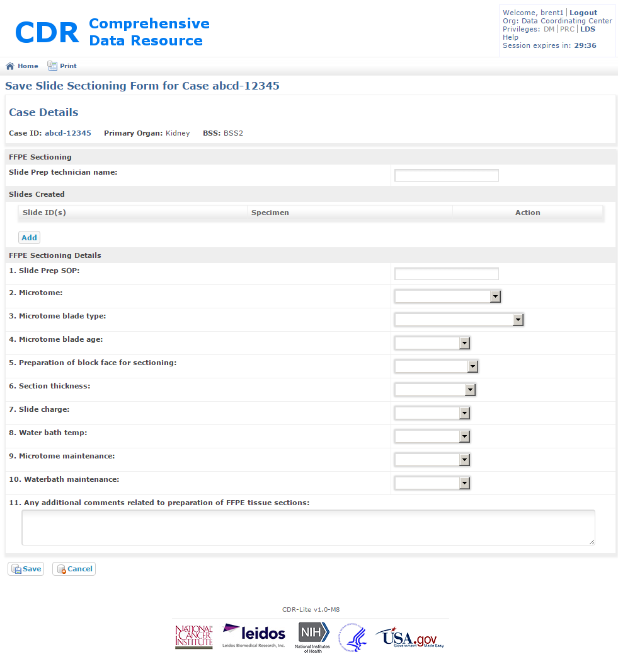

Figure 48 - Creating a Slide Sectioning Form for a Case

1. For each slide created, Press the Add button in the Slides Created box. This brings up an ancillary window for entering one Slide ID and associated Specimen ID, Figure 44:

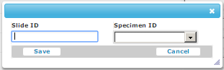

Figure 49 - Ancillary Window for Entering Slide ID and Associated Specimen ID

Typically, the slide ID comes from pre-labeled slides or a label, in accordance with a study’s SOP. The Specimen ID is a pull down menu, with the IDs of the specimens for the current case. Enter these two values and press **Save**.

1. Enter the fields as follows:
   1. Slide Prep SOP: – Version number of the Slide Preparation SOP in effect
   2. Microtome: – Single select giving the manufacturer of the Microtome used for embedding the tissue. If not Ergostar, then select "Other", and use the Specify box for entering the manufacturer’s name
   3. Microtome blade type: - Single select giving type of blade in the Microtome used in producing the tissue slide. If not “Low profile Sakura Accu-Edge”, then select "Other", and use the Specify box for entering the type of blade’s name
   4. Microtome blade age: – Single select giving type of blade in the Microtome used in producing the tissue slide. If not “Fresh”, then select "Other", and use the Specify box for entering the description of the blade’s age
   5. Preparation of block face for sectioning: – Single select giving description of the block preparation for the Microtome. If not “20 Minutes on Ice”, then select "Other", then use the Specify box for entering the preparation
   6. Section thickness: – Single select giving description of the section produced by the Microtome. If not “4-5 micrometers”, then select "Other", and use the Specify box for entering the section thickness
   7. Slide charge: - Single select giving description of the charge associated with the slide glass surface. If not “Charged” (for Silanized slides), or “Uncharged” (for neutral slides), then select "Other", and use the Specify box for entering the charge details
   8. Water bath temp: - Single select giving description of the temperature of the water bath. If not “43 +- 2 Degree C”, then select “Other”, and use the Specify box for entering the water bath temperature
   9. Microtome maintenance: - Single select giving a description of the routine maintenance period for the microtome. If not “Daily”, then select "Other", and use the Specify box for entering the deviations from routine maintenance
   10. Waterbath maintenance: - Single select giving a description of the routine maintenance period for the water bath. If not “Daily”, then select "Other", and use the Specify box for entering the deviations from routine maintenance
   11. Any additional comments related to preparation of FFPE tissue sections: – Storage place for any additional observations related to this set of slide preparations.
2. Click on **Save**. CDR does a first check on the entries. If a problem is found, an error message shows in red at the top of the screen; after making the correction, click **Save** at the bottom of the form. When there are no problems found, press the **Submit** button at the bottom of the form. When submitting the form, it signals the data management team that this record is ready for review. Click on the Case ID (at the top of the screen, under Case Details, to resume data entry.

## Adding a Slide Prep and Staining Form

Most pathology reviews require slide preparation. Details of slide preparation described as part of the study SOPs. This form records the major steps in preparation.

### Process

1. On the View Candidate Record Details Screen, Figure 17, find the Case List item. Click on the text in blue, to the right, Add Case Record. CDR goes to the Create Slide Prep Screen, Figure 50.
2. The following information fills automatically from information previously entered:

Case ID - Unique ID given to the case associated with this blood form. Clicking the text in blue navigates CDR to the Show Case Record Details Screen, Figure 37.

Primary Organ - Organ in the study associated with this case.

BSS – The biospecimen source site associated with this collection.

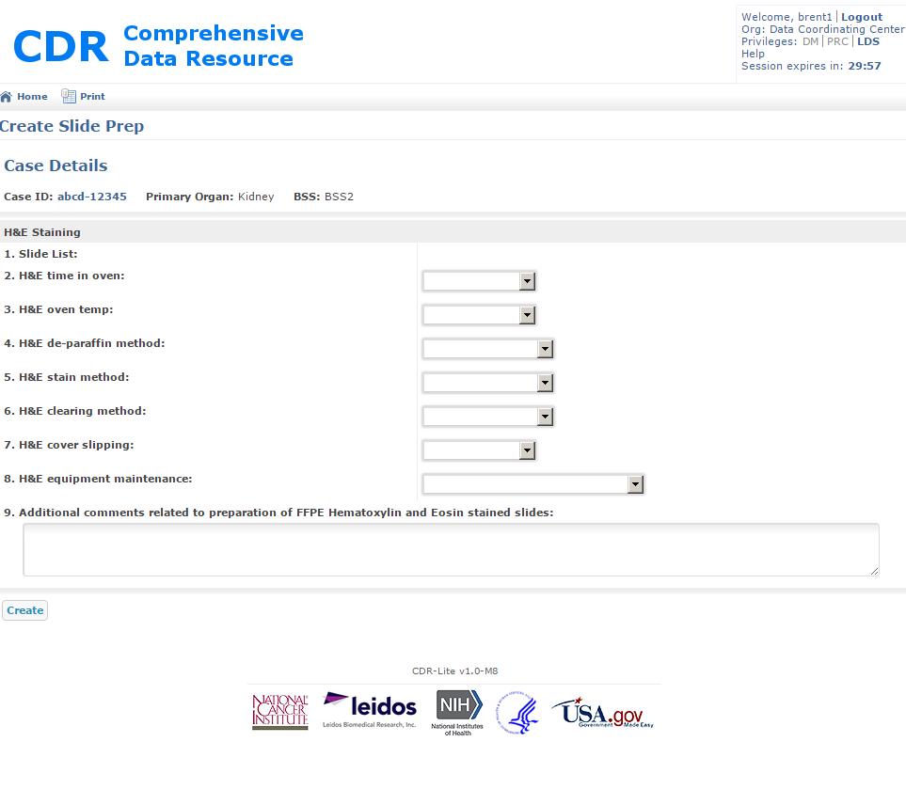

Figure 50 - Creating a Slide Prep form

1. Enter the fields as follows:
   1. Slide List: – Check box list of slides previously entered via a Slide Sectioning form (Section 3.21). Select all sides described in this form
   2. H&E time in oven: – Single select menu giving a description of the period for heating the slide in the oven for H&E staining. If not “20 minutes”, then select "Other", and use the Specify box for recording the duration
   3. H&E oven temp: - Single select menu giving a description of the temperature in the oven for H&E staining. If not “60◦ C”, then select“Other”, and use the Specify box for recording the temperature and scale
   4. H&E de-paraffin method: - Single select menu giving a description of method used for de-paraffin before H&E staining. If not “Manual”, or “Automated Stainer”, then select “Other”, and use the Specify box for recording the de-paraffin methodology
   5. H&E stain method: - Single select menu giving a description of method used for H&E staining. If not “Manual”, or “Automated Stainer”, then select "Other", and use the Specify box for recording the staining methodology
   6. H&E clearing method: – Single select menu giving a description of method used for clearing. If not “Manual”, or “Automated Stainer”, then select "Other", and use the Specify box for recording the clearing methodology
   7. H&E cover slipping: – Single select menu giving a description of method used for applying the slide cover. If not “Manual”, then select "Other", and use the Specify box for recording the cover slipping methodology
   8. H&E equipment maintenance: – Single select menu giving a description of the maintenance periods used for the H&E equipment. If not “Daily, Weekly, Bi-Monthly, Per SOP”, then select "Other", and use the Specify box for recording the frequency of equipment maintenance
   9. Additional comments related to preparation of FFPE Hematoxylin and Eosin (H&E) stained slides: - Additional free-text field for recording any notes, or observations about the H&E staining for the slides covered by this form
2. Click on **Create**. The form contents are automatically reviewed for completeness and initial accuracy. If there are problems, then those irregularities list in red at the top of the form. Edit the form appropriately, and repeat clicking on **Create,** or **Save.** After correcting all problems, a **Submit** button appears at the bottom of the screen; press this button to request DM review of the entries. After submitting, the screen shows a read-only version of the form, and gives an option to **Resume Editing**. In order to continue to the next step, click on the blue **CDR** logo at the top of the page. CDR goes to the Show Case Record Details for the case number just entered. After successfully adding the case, a note shows under the title.

## Adding a Surgical Pathology Form

This section is unlike the other CRFs, the Surgical Pathology Form is a form upload from a scanned image, or file. There can only be one file for the Surgical Pathology Form at a time, although the upload may contain multiple pages in that one file.

If no file is currently loaded, then the status reads as **Not Started**, and an up-arrow icon shows. If a file is currently loaded, then the status is **Uploaded**, two icons show: a down-arrow, and a trashcan. The down-arrow starts the file retrieval (from CDR to the local machine). The trashcan deletes the file currently uploaded, making room for a subsequent file upload.

Upload a file

1. On the Show Case Record Details Screen, Figure 37, find the Surgical Pathology Form. Click on the up-arrow icon. CDR shows the file upload screen, Figure 51.

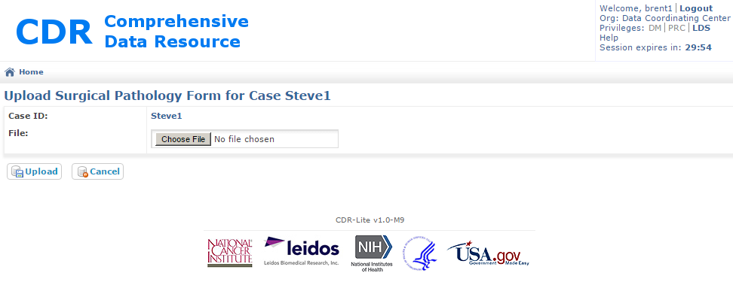

Figure 51- Upload Surgical Pathology Form

1. Click on the “Choose File” button for browsing to a file on the local machine.
2. Click on **Upload** to copy the selected file to CDR, Cancel to abort the upload.

Remove a file previously uploaded:

1. On the Show Case Record Details Screen, Figure 37, find the Surgical Pathology Form. Click on the trashcan icon. CDR asks for conformation that this file should be deleted; answer yes.

## Adding a Clinical Data Entry Form

The Clinical Data Entry form records information about the cancer and disease ancestry information related to the case.

### Process

1. On the Show Candidate Record Details Screen, Figure 17, find the Case List item. Click on the text in blue, to the right, **Add Case Record**. CDR goes to the Create Clinical Data Entry screen, Figure 52.
2. The following information fills automatically from information previously entered:

Case ID - Unique ID given to the case associated with this blood form. Clicking the text in blue navigates CDR to the Show Case Record Details Screen, Figure 37.

Primary Organ - Organ in the study associated with this case.

BSS – The biospecimen source site associated with this collection.

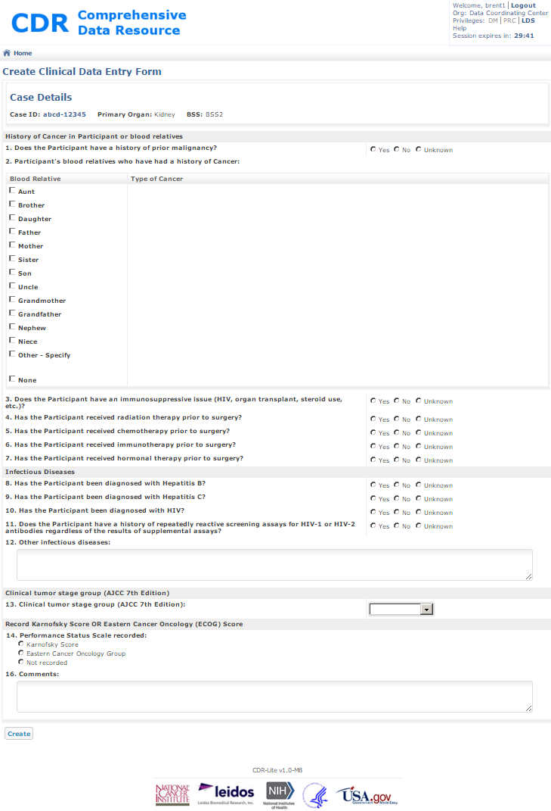

Figure 52 - Creating a Clinical Data Entry Form for a Case

1. Enter the fields as follows:
   1. Does the Participant have a history of prior malignancy? – Required; Select one of “Yes”, “No”, or “Unknown.”
   2. Participant's blood relatives who have had a history of Cancer: – Required. Multiple-select for most entries; Click on the check box next to the relations of blood-relatives having a history of cancer When creating a relation, a required text box is shown for recording the type of cancer. If two of the same relation has had cancer, then enter one on the appropriate relation, and the second under “Other – Specify.” If no relations have had cancer, then check on the final box, “None.” If “None" is selected, the no other boxes may be checked.
   3. Does the Participant have an immunosuppressive issue (HIV, organ transplant, steroid use, etc.)? – Required; Select one from the list of “Yes”, “No”, or “Unknown.” If "Yes" is selected, then a series of check boxes are shown; select all that are applicable: “HIV,” “Organ transplant,” “Chronic systemic steroid use,”, and “Other – Specify”. If "Other" is selected, a text entry box is shown for recording the immunosuppressive issue).
   4. Has the Participant received radiation therapy prior to surgery? – Required; Select one from the list of “Yes,” “No,” or “Unknown.” If Yes is selected, then a blank table shows, along with an **Add** button, in blue. Pressing the Add button expands the form as shown in Figure 53. Describe the details of a radiation therapy in the large text box; the calendar pull down allows for entry of the date of the completion of radiation therapy; if the exact date is not known, enter the number of years since given therapy. Pressing Save adds a line to the table in question 4. If, after entering a radiation therapy prior to surgery, the entry needs changing, use the delete button in the right hand column, and re-enter the correct data in a new record.

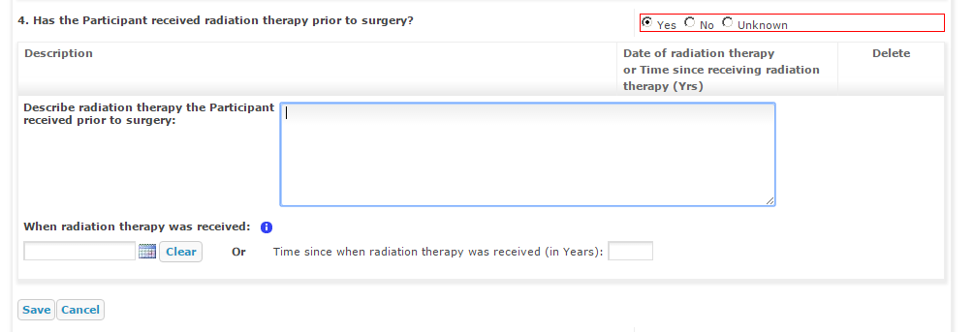

Figure 53 - Expanded Question 4 for Entering Details of Radiation Therapy

* 1. Has the Participant received chemotherapy prior to surgery? – Required; Select one from the list of “Yes”, “No”, or “Unknown.” If Yes is selected, then a blank table shows, along with an **Add** button, in blue. Pressing the **Add** button expands the form as shown in Figure 54. Use the large text box for describing the details of chemotherapy; the calendar pull down allows for entry of the date of the completion of chemotherapy; if the exact date is unknown, enter the number of years since given therapy. Pressing **Save** adds a line to the table in question 5. If, after entering chemotherapy prior to surgery, the entry needs changing, use the delete button in the right hand column, and re-enter the correct data in a new record.

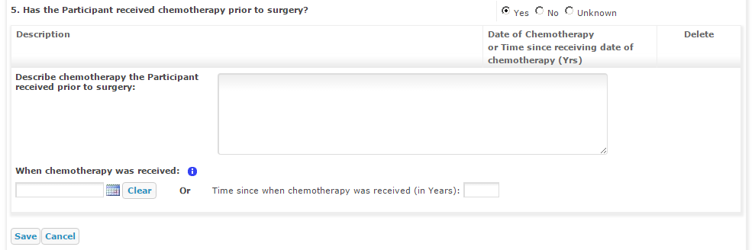

Figure 54 - Expanded Question 5 for Entering Details of Chemotherapy

* 1. Has the Participant received immunotherapy prior to surgery? – Required; Select one from the list of “Yes”, “No”, or “Unknown.” If Yes is selected, then a blank table shows, along with an **Add** button, in blue. Pressing the **Add** button expands the form as shown in Figure 55. Use the large text box for describing the details of an immunotherapy; the calendar pull down allows for entry of the date of the completion of immunotherapy; if the exact date is unknown, enter the number of years since given therapy. Pressing **Save** adds a line to the table in question 6. If, after entering an immunotherapy prior to surgery, the entry needs changing, then use the delete button in the right hand column, and re-enter the correct data in a new record.

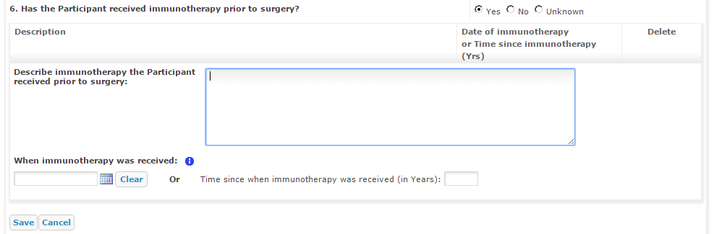

Figure 55 - Expanded Question 6 for Entering Details of Immunotherapy

* 1. Has the Participant received hormonal therapy prior to surgery? – Required; Select one from the list of “Yes”, “No”, or “Unknown.” If Yes is selected, then a blank table shows, along with an **Add** button, in blue. Pressing the **Add** button expands the form as shown in Figure 56. Use the large text box for describing the details of a hormonal therapy; the calendar pull down allows for entry of the date of the completion of hormonal therapy; if the exact date is unknown, enter the number of years since given therapy. Pressing **Save** adds a line to the table in question 7. If, after entering a hormonal therapy prior to surgery, the entry needs changing, then use the delete button in the right hand column, and re-enter the correct data in a new record.

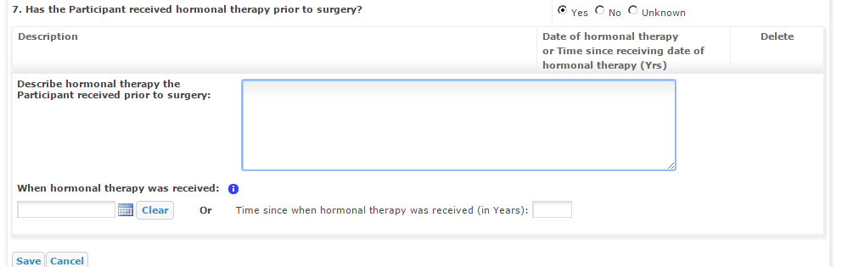

Figure 56 - Expanded Quesion 7 for Hormonal Therapy

* 1. Has the Participant been diagnosed with Hepatitis B? – Required; Select one from the list of “Yes”, “No”, or “Unknown”
  2. Has the Participant been diagnosed with Hepatitis C? – Required; Select one from the list of “Yes”, “No”, or “Unknown”
  3. Has the Participant been diagnosed with HIV? – Required; Select one from the list of “Yes”, “No”, or “Unknown.”
  4. Does the Participant have a history of repeatedly reactive screening assays for HIV-1 or HIV-2 antibodies regardless of the results of supplemental assays? – Required; Select one from the list of “Yes”, “No”, or “Unknown”
  5. Other infectious diseases: – Free text field for noting all infectious diseases for which this patient has been diagnosed
  6. Clinical tumor stage group (AJCC 7th Edition): - Required. Single select pull down menu for entering the progress stage of the tumor. Select one of “Stage 1”, “Stage 2”, “Stage 3”, or “Not Available”
  7. Performance Status Scale recorded: – Required. Select one of the performance scales: “Karnofsky Score”, “Eastern Cancer Oncology Group”, or “Not Recorded.”   
     If Karnofsky Score is selected, the form expands, allowing for selection of the patient status, shown in Figure 57.

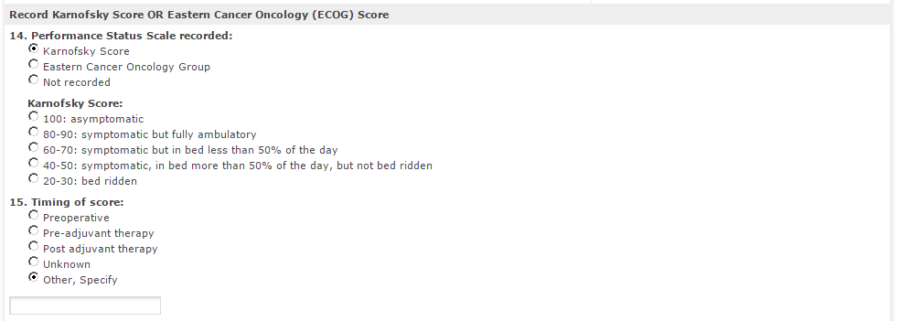

Figure 57 - Expanded Question 14 for Karnofky Score

When selecting the Eastern Cancer Oncology Group, the form expands, as shown in Figure 58. Select one of the ECOG Functional Performance Status.

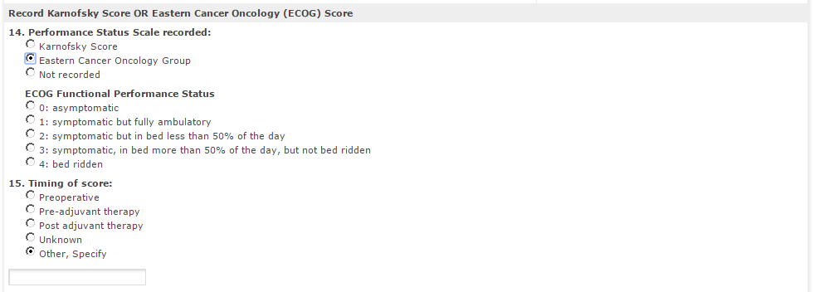

Figure 58 - Expanded Question 14 for Eastern Cancer Oncology (ECOG) Score

* 1. Timing of score: - This field is not visible, unless the answer to xiv is “Karnofsky Score” or “Eastern Cancer Oncology Group” (See lower half of Figure 57, or Figure 58). If visible, select on of “Preoperative”, “Pre-adjuvant therapy”, “Post adjuvant therapy”, “Unknown”, or “Other, Specify.” If the answer is “Other, Specify” a text entry field displays for recording the phase of timing
  2. Comments: - - Additional free-text field for recording any notes, or observations about the clinical data for this case

1. Now, click **Create,** or **Save**. The form contents automatically reviewed for completeness and initial accuracy. If there are problems, then those irregularities list in red at the top of the form. Edit the form appropriately, and repeat clicking on **Create,** or **Save.** After correcting all problems, a **Submit** button appears at the bottom of the screen. Press this button to request DM review of the entries. After submitting, the screen shows a read-only version of the form, and gives an option to **Resume Editing**. In order to continue to the next step, click on the blue **CDR** logo at the top of the page. CDR goes to the Show Case Record Details for the case number just entered. When successfully added, a note shows under the title.

# PRC Role

The Pathology Resource Center (PRC) reviews the pathology of the specimens, by observing slides, and reviewing entries recorded earlier by the BSS. When the images are ready for review by the PRC, an automatic alert comes from the CDR to the PRC team stating images are ready. The CDR records the PRC case assessment in the PRC Review form.

**NOTE:** Cases may be reviewed solely based on the images once made available to the PRC or glass slides may be used when images are insufficient for interpreting the case findings completely

In general, the PRC follows the following procedure. The process varies from study to study**.**

1. A CDR Alert indicates images are now available.
2. A PRC Pathologist gets the assignment for reviewing the case by the Director or their delegate.
3. In advance of case review, the pathologist reviews clinical and case collection data as provided within the forms for the case.
4. The assigned PRC Pathologist reviews the images.
5. The pathologist reviews the images.

**NOTE:** Pathologists review all tissues to confirm the following:

a) The presence of the intended morphology,

b) The presence and degree of autolysis,

c) The presence of pathologic findings (e.g., inflammation, hemorrhage, neoplasms), and

d) Verification of aliquot amounts/tissue pieces as specified in the applicable SOP.

1. Upon identifying any issues, the PRC works with the relevant parties ensuring their complete resolution prior to assigning a final specimen status. Issues may include:

* Requests for recuts for verification or special stains,
* Mislabeled images or slides,
* Broken slides,
* Extraneous tissues,
* Sampling errors, and
* Unexpected findings

## Pathology Case Summary Report

The CDR Pathology Case Summary Report documents all findings and issues identified from the PRC review in a timely fashion.

### Process

* + 1. Log in to CDR with an account that has or can take on the PRC role.
    2. In the upper right corner of the screen, in the “Privileges:” row, click on “PRC”, as shown in Figure 59.

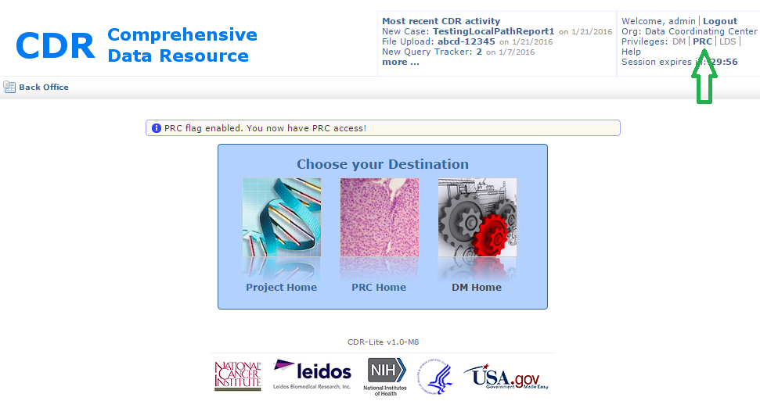

Figure 59 - Enabling PRC Role (Green Arrow) and Message

* + 1. If the message, “PRC flag enabled. You now have PRC access!” does not show; see the CDR Admin about having the account adjusted for this role.
    2. Click on the picture or text PRC Home. CDR goes to the PRC Home page, for selecting a study. Click on the line with the current study name. This displays the study specific PRC Home screen (Figure 60).

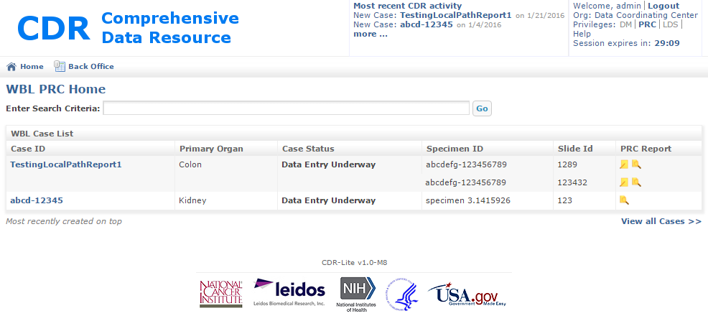

Figure 60 - Study Specific (WBL) PRC Home screen

1. Each line in the table shows information on a case-by-case basis. The final column, PRC Report, has one or two icons: the pencil-and-paper goes to the PRC Report Editor, while the magnifying glass goes to the PRC Report Viewer. If only the magnifying glass shows, this means there already is a saved PRC Report for this Case/Specimen/Slide ID. Click on the pencil-and-paper icon. CDR now shows the Edit PRC Report, Figure 61.

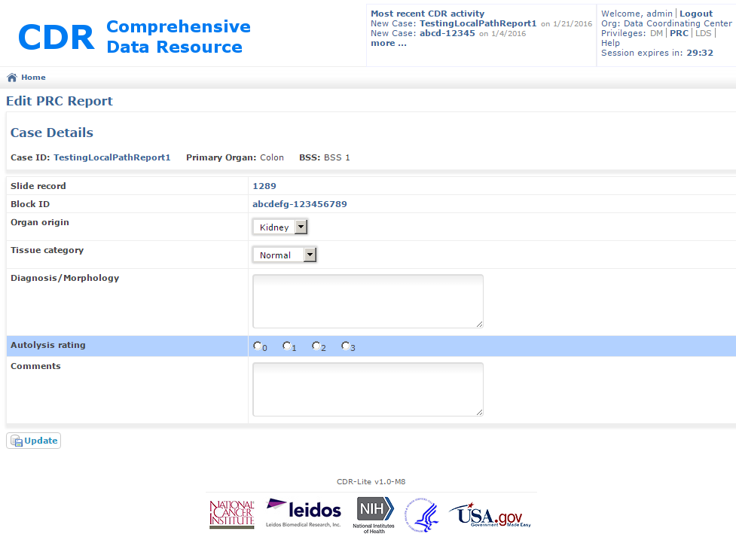

Figure 61 - Edit PRC Report Screen

1. The following information fills automatically from data previously entered:

Case ID - Unique ID given to the case associated with this blood form. Clicking the text in blue navigates CDR to the Show Case Record Details Screen, Figure 37

Primary Organ - Organ in the study associated with this case

BSS – The biospecimen source site associated with this collection

Slide Record – The CDR slide ID

Block ID – The specimen ID for the gross tissue from which the slide was cut

1. Enter the following fields:
2. Organ of origin: - Pull down menu selecting the organ associated with the block.
3. Tissue category: - Pull down menu specifying “Normal”, “Diseased”, or “Tumor”
4. Diagnosis/Morphology: - Free text describing the PRC evaluation of the diagnosis/morphology.
5. Autolysis rating: Select only one of the four possible values.
6. Comments: - For each tissue should include:

* The number of tissue pieces,
* The presence of extraneous tissue, e.g., fat, its location (internal or external),
* Relative (%) or actual size of extraneous tissue,
* Pathologic findings, e.g., congestion, hemorrhage, inflammation, atrophy
* Specific entities such as Hashimoto’s thyroiditis, cirrhosis, diabetic; specified to facilitate data base searches.

1. When the Pathology team completes the PRC Report, the reviewing pathologist approves and submits the Report. Click on **Update**. Data Management then reviews the PRC Report available within the CDR to all approved parties.

In the event that a PRC Report requires modification, the PRC makes a new instance of the report, assigning an incremental serial version number.

# DM Role

The role of data management is to ensure that the data in CDR is of high quality, without errors, and complete. The quality of the data is central to the whole process; it serves as the basis for analysis, publications, and future policy implications. Good clinical and biospecimen data, which is well organized, easily accessible, and properly cleaned, is essential in producing quality products.

A data management review checks for, forms having incomplete, incorrect, inaccurate, irrelevant items in the dataset. CDR automates some of these data checks are automated (e.g., checking that an age is a positive number); some of the checks are manual (e.g., checking to see if birth date is consistent with consenting). CDR performs automatic checks when information enters into CDR, so the user gets immediate feedback. Querying refers to the semi-automated process for manual checks, and resolution.

## Setting/Clearing the DM role flag

The DM role flag toggles access to the Data Manager home, and activities found there. Before setting the DM flag, the CDR Administrator must add the “DM_ROLE” to the user account, also known as DM enabled.

Additionally, the use of the query tracker requires setting the LDS flag. This also requires the CDR Administrator to add “LDS_ROLE” to this user account.

### Process

1. Log in to CDR with a user account that is DM enabled.
2. In the upper right corner of any screen (in Figure 73, the example is of the Home screen), click on both the LDS and the DM setting in the **Privileges:** line. This turns on the LDS and DM flags, enabling the viewing and editing of LDS information. A note shows on the screen saying, “DM flag enabled. You have data manager access!”

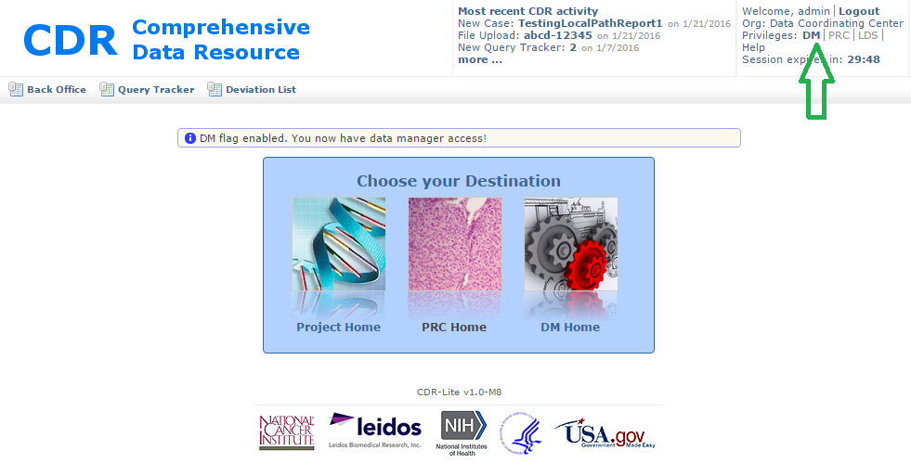

Figure 62 - Home screen, with Green Arrow indicating Location of DM flag

1. If this note does not display, or the LDS and DM text does not display in bold, contact the CDR administrator about the privileges for this account.
2. To remove DM access, click on the DM letters again. The DM letters no longer display in bold. The account no longer has access to DM Home.
3. To show the DM Home page, Figure 63, click on the “DM Home” text, or the icon associated with it.

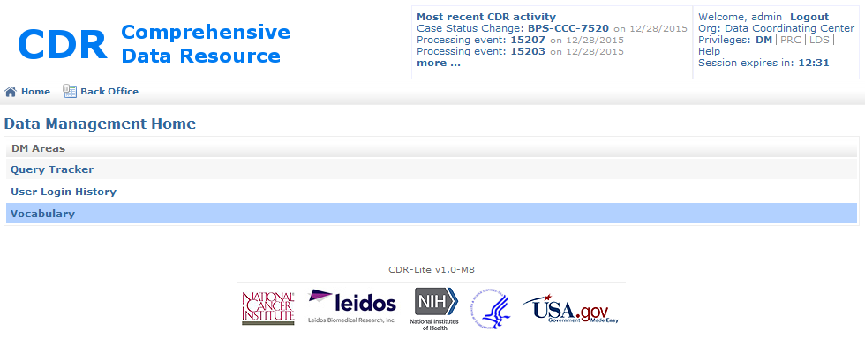

Figure 63 - DM Home Screen

## Understanding the Data Management Home page

The Data Management home page has three tools. The “Query Tracker” is the tool most used in the data cleaning effort. The “User Login History” is a reporting tool for user logins. The “Vocabulary” tool allows for setting various values, and other functions.

## Using the Query Tracker tool

Queries are the primary mechanism for coordinating data cleaning activities. When questions arise during a data management review of information on a candidate, case, or other issue, the data management team uses the query tracker for creating a new query. The new query associates with a case record or candidate record by the unique ID. When a query is activated for a candidate or case, the QT count increments. On the study home page, Figure 4, the QT count shows in red. When each BSS reviews their home page, clicking on the red number for that line item brings up the query record.

### Process

1. Log in to CDR with a user account that is DM enabled.
2. In the upper right corner of any screen (in Figure 73, the example is of the Home screen), click on the DM setting in the **Privileges:** line. This turns on the DM. A note shows on the screen saying, “DM flag enabled. You have data manager access!” Next click on the LDS setting, turning on the LDS flags.
3. Now click on the DM Home screen, and select the Query Tracker item. CDR now shows the Query List screen. The list displayed shows the list of all queries, Figure 64.

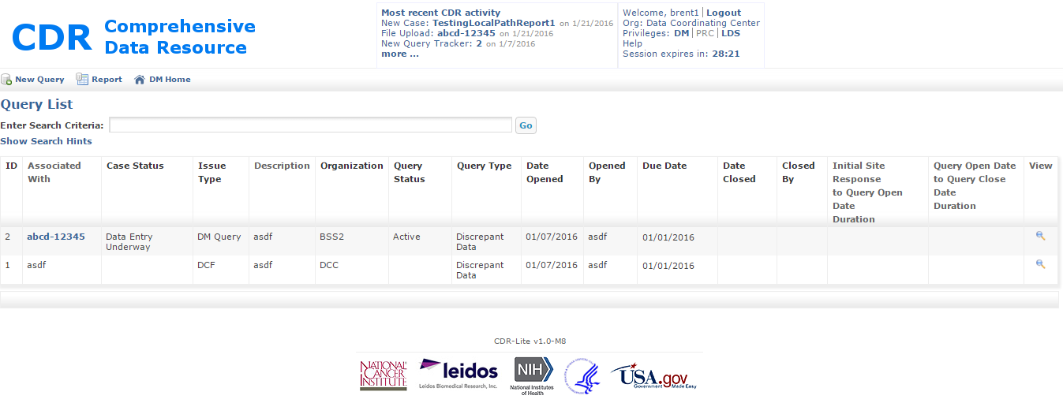

Figure 64 - Query List Screen in the Query Tracker

1. Search for a query to review. The description of searching is the same as in section 3.1.2.

## Creating a New Query

Only the data manager can generate a query. Frequently, queries are the result of a data cleansing review of candidate or case related information. While the process of reviewing is outside the scope of this document, after finding an issue, use the following steps in creating the query.

### Process

1. Log in to CDR with a user account that is DM enabled.
2. In the upper right corner of any screen (in Figure 73, the example is of the Home screen), click on the DM setting in the **Privledges:** line. This turns on the DM. A note shows on the screen saying, “DM flag enabled. You have data manager access!” Next clicking on the LDS setting turns on the LDS flags, enabling the viewing / editing of limited data set case information.
3. To create a new query, click on the Create Query icon. CDR displays the “Create Query” screen, Figure 65 - Create Query Screen.

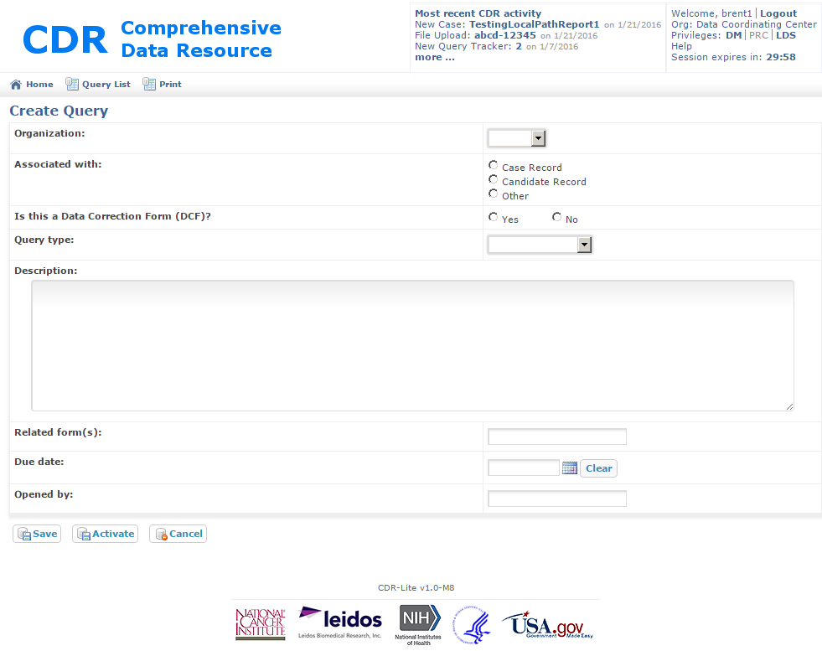

Figure 65 - Create Query Screen

1. Fill out as many of the fields as necessary for describing the issue:
   1. Organization: - Pull down list of all organizations defined in CDR. This list reflects the Organizations created by the Admin when setting up this study
   2. Associated With: - Select one of the items associated with the query, Case, Candidate, or Record ID
   3. Is this a Data Correction Form (DCF)? Required; enter “Yes” or “No” if this query is about problems related to static field values provided by the BSS.
   4. Description: - Free text. This is for describing the issue. Include which form, and field, or fields, have an issue, describe the issue.
   5. Related Forms: - CDR screens, or paper forms, that are associated with the issue
   6. Due Date: - Required calendar select; sets the completion date on responding to this query
   7. Opened by: - Required field giving the name of the data manager opening this query
2. Now click on the **Activate** button at the bottom of the screen. This brings up the “Show Query” screen, Figure 66.

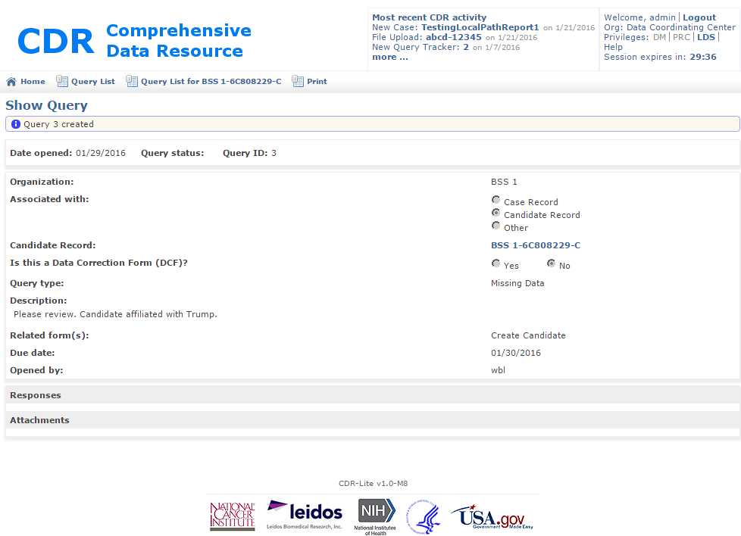

Figure 66 - Show Query after a new Query Creation

## Viewing an Existing Query

Responses to queries use a process of Responses and Attachments. Data Management review of a response requires the reviewer view the existing query.

### Process

1. Log in to CDR with a user account that is DM enabled.
2. In the upper right corner of any screen (in Figure 73, the example is of the Home screen), click on the DM setting in the **Privledges:** line. This turns on the DM. A note shows on the screen saying, “DM flag enabled. You have data manager access!” Next, clicking on the LDS setting, turning on the LDS flags, enabling the viewing, and editing of limited data set case information.
3. Click on the View icon in the very last column of the Query List, Figure 64. This brings up the Show Query screen, Figure 66.

## Closing Existing Query

### Process

1. Log in to CDR with a user account that is DM enabled.
2. In the upper right corner of any screen (in Figure 73, the example is of the Home screen), click on the DM setting in the **Privledges:** line. This turns on the DM. Next, click on the LDS setting, to turn on the LDS flags, enabling the viewing / editing of limited data set case information. A note shows on the screen saying, “DM flag enabled. You have data manager access!”
3. Click on the View icon in the very last column of the Query List, Figure 64. This brings up the Show Query screen, Figure 66.
4. After determining what needs correction. Look at Sites response in the Responses section. Determine if the response addresses the subject of the query (e.g., was the change made in the CDR, was an explanation provided, was existing data verified).
5. If the site response addresses the query, then click on the “Resolve” button at the bottom of the screen. A confirmation dialog box pops up and asks if the query was resolved. If yes, click “OK.” A message shows at the top of the screen stating that the query was marked as resolved.
6. If the site response does not satisfactorily address the query, there are two options. The first option requires that you use the Response section and ask for additional information or clarification (and then click on the “Reactivate” button, sending the query back to the BSS). The second option would be determining if that site cannot offer additional information, mark the query as unresolved by clicking on the **Unresolved** button. The status of the query shown in the Query List page displays not resolved.
7. Verify that the query does not require further action, and then close out the query by clicking on the “Close” button at the bottom of the Show Query screen.

Note: The **RESOLVE** status is useful for marking queries for additional action (but not site response) by the Data Management team.

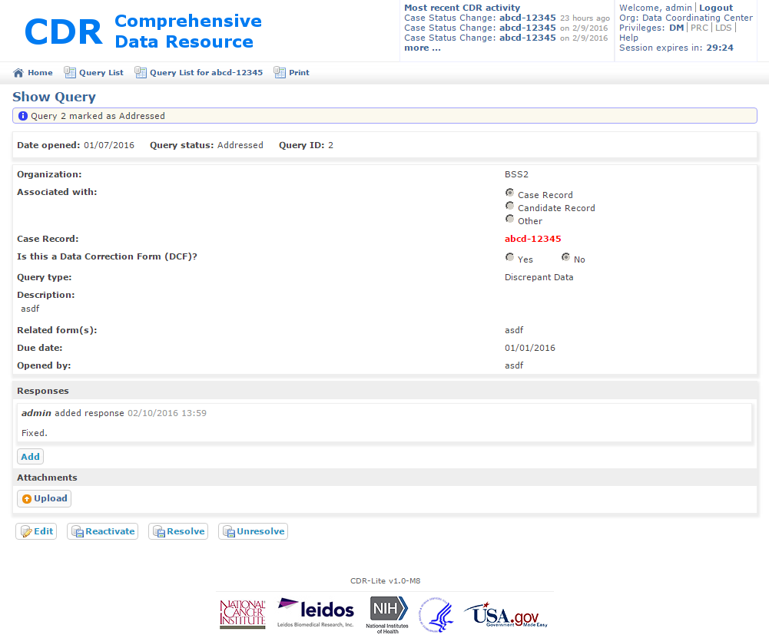

Figure 67 - Show Query Addressed Query . Note Additional Buttons at Bottom.

## Using the User Login History tool

The User Login History tool gives the Data Manger the ability to look at login times, organizations, whether the user logged out, or their session timed out. The reports can be limited to any period (default is today), any organization, or any specific user.

### Process

1. Go to the Data Management Home page, and click on the User Login History tool. CDR displays the basic reporting tool, showing all of today’s activity, Figure 68.

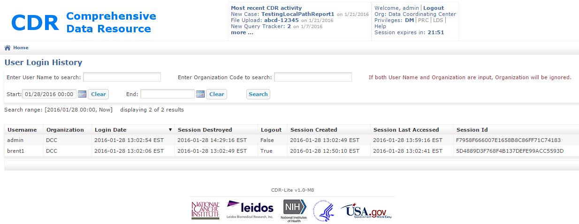

Figure 68 – CDR User Login History tool

1. The search fields are as follows:
   1. Enter User Name to search: - This is the account user name, not the personal name
   2. Enter Organizational Code to search: - This is the code for the organization entered when creating the organization in CDR. Only Organizational Code or Name can be entered, but not both.
   3. Start: - Calendar entry for the earliest date/time for the report. Default is today at midnight.
   4. End: - Calendar entry for the latest date/time for the report. Default is now.
2. After entering the desired values into the search fields, click on the Search button. The list at the bottom of the screen updates, showing those login records matching the search

## Using the Vocabulary tool

### Process

1. Go to the Data Management Home page, and click on the Vocabulary tool. CDR displays the Vocabulary tool, Figure 69, showing all the vocabulary items which may be dynamically customized.

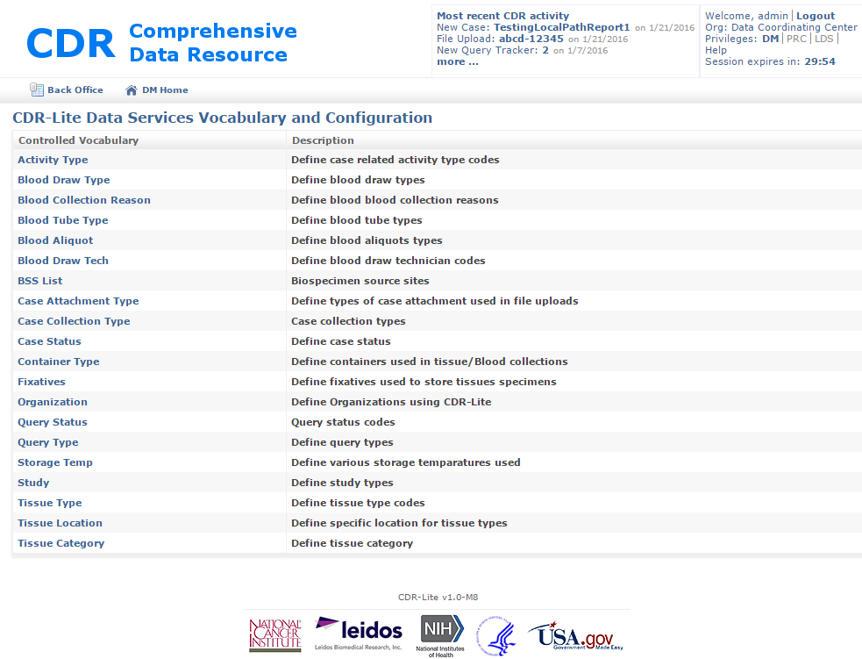

Figure 69 - CDR-Lite Data Services Vocabulary and Configuration

Table 7 shows the vocabulary items, which role can modify them, and the forms associated with those vocabulary items.

Table 7 - Vocabulary Items and Access Restrictions

| **Name** | **Definition** | **User Roles Having Access** | **Associated Forms** |
| --- | --- | --- | --- |
| Activity Type | Define case related activity type codes | Admin_Role | CaseRecord List  Case Detail page |
| Blood Draw Type | Define blood draw types | Admin_Role, DM_Role | Edit Blood Draw |
| Blood Collection Reason | Define blood collection reasons | Admin_Role, DM_Role | Edit Blood Draw |
| Blood Tube Type | Define blood tube types | Admin_Role, DM_Role | Edit Blood Draw |
| Blood Aliquot | Define blood aliquots types | Admin_Role, DM_Role | Edit Blood Draw |
| Blood Draw Tech | Define blood draw technician codes | Admin_Role, DM_Role | Edit Blood Draw |
| BSS List | Biospecimen source site codes; List created by adding an Organization, and declaring it a BSS. | Admin_Role, DM_Role (View only) | Numerous |
| Case Attachment Type | Define types of case attachment used in file uploads | Admin_Role, DM_Role |  |
| Case Collection Type | Case collection types | Admin_Role, DM_Role |  |
| Case Status | Define case status | Admin_Role, DM_Role | Create Case Record |
| Container Type | Define containers used in tissue/Blood collections | Admin_Role, DM_Role | Create Specimen Record |
| Fixatives | Define fixatives used to store tissues specimens | Admin_Role, DM_Role | Create Specimen Record, Create Tissue Receipt and Dissection Form, |
| Organization | Define Organizations using CDR-Lite | Admin_Role, DM_Role | User Login History |
| Query Status | Query status codes | Admin_Role, DM_Role |  |
| Query Type | Define query types | Admin_Role, DM_Role |  |
| Storage Temp | Define various storage temperatures used | Admin_Role, DM_Role | Create Specimen Record |
| Study | Define study types | Admin_Role, DM_Role | Home, Numerous |
| Tissue Type | Define tissue type codes | Admin_Role, DM_Role | Create Specimen Record |
| Tissue Location | Define specific location for tissue types | Admin_Role, DM_Role | Create Specimen Record |
| Tissue Category | Define tissue category | Admin_Role, DM_Role | Edit PRC Report |

1. Click on the item of interest. This example uses the “Blood Draw Type,” but all editable vocabulary items work similarly. Clicking on “Blood Draw Type” brings up the “BloodDrawType List,” Figure 70.

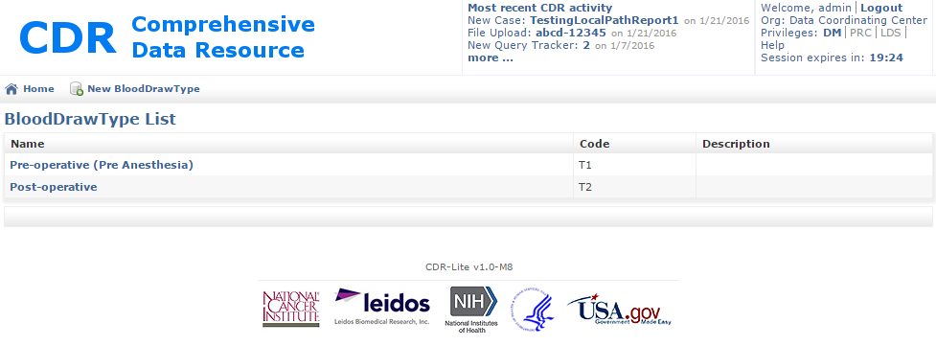

Figure 70 - BloodDrawType List (Example of modifying vocabulary Lists)

1. The two previously defined blood-draw types show in the list, along with a type code. To edit either of those previous entries, click on the name. To add an additional blood draw type, click on the “New BloodDrawType” icon. CDR now displays the “Create BloodDrawType” screen, Figure 71.

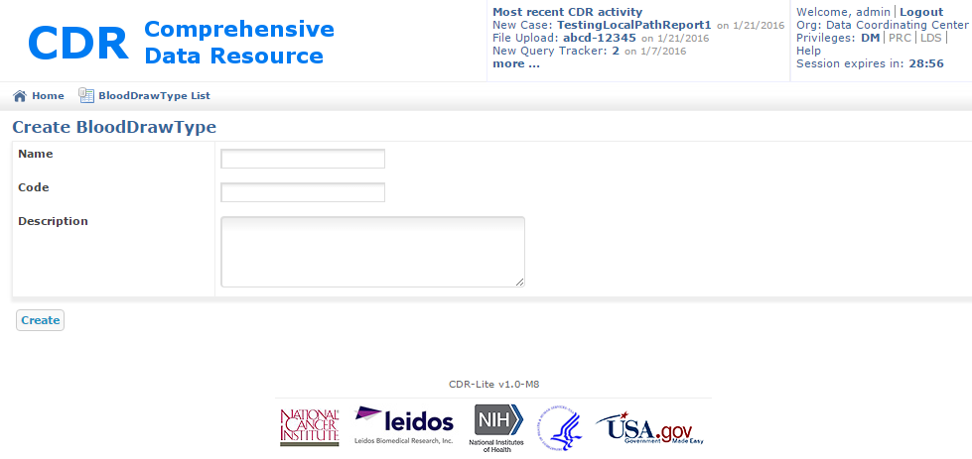

Figure 71 - Create BloodDrawType Screen

1. Enter the fields as follows:
2. Name: – Required; Title of additional blood draw type, for example “Six-Month Follow-up”
3. Code: – Required. Short code used for tracking this type of blood draw.
4. Description: – Any additional information about this type of blood draw; for example, a reference to the SOP containing details.
5. Now, click on Create. CDR now displays the “Show BloodDrawType” screen, giving a message that the blood draw type was created successfully, Figure 72.

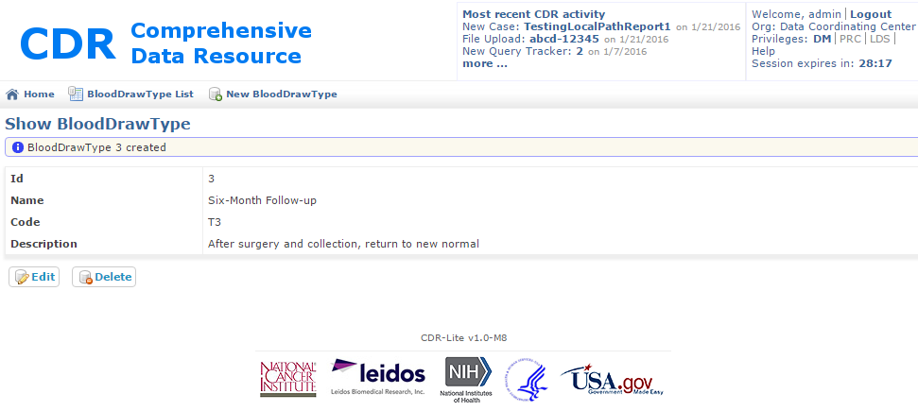

Figure 72 - Show BloodDrawType after Adding New Type

1. If all is acceptable, click on the Home icon, to return to DM Home, BloodDrawType List, to see the updated list, or New BloodDrawType for adding additional draws.
2. A similar process works for each of the editable items in Vocabulary. Once changed, the modified lists become available on the associated forms.

# LDS Role

The Limited Data Set (LDS) is a limited set of identifiable patient information as defined in the Privacy Regulations issued under the Health Insurance Portability and Accountability Act, better known as “HIPAA.” CDR uses a LDS Role flag (sometimes just called the “LDS Role”) in distinguishing whether a user may view or modify LDS fields. Unlike the other roles in CDR, the LDS Role flag controls access to Limited Data Set (LDS) information for all users, regardless of any role settings.

When a user attempts to show a record containing a field having LDS information, but does not have the LDS flag set, that field displays with the message “**REDACTED (No LDS privilege)”** in red.

One restriction on the use of the LDS Role flag is that it must be set *BEFORE* adding any other roles.

## Setting/Clearing the LDS role flag

The LDS role flag toggles protection of PII/PHI field contents. Before setting the LDS flag, the CDR Administrator must add the “LDS_ROLE” to the user account

### Process

1. Log in to CDR with a user account that is LDS enabled.
2. In the upper right corner of any screen (in Figure 73 , the example is of the Home screen), click on the LDS setting in the **Privileges:** line. This turns on the LDS flag, enabling the viewing and editing of LDS information. A note shows on the screen saying, “LDS flag enabled. You have full LDS access!”

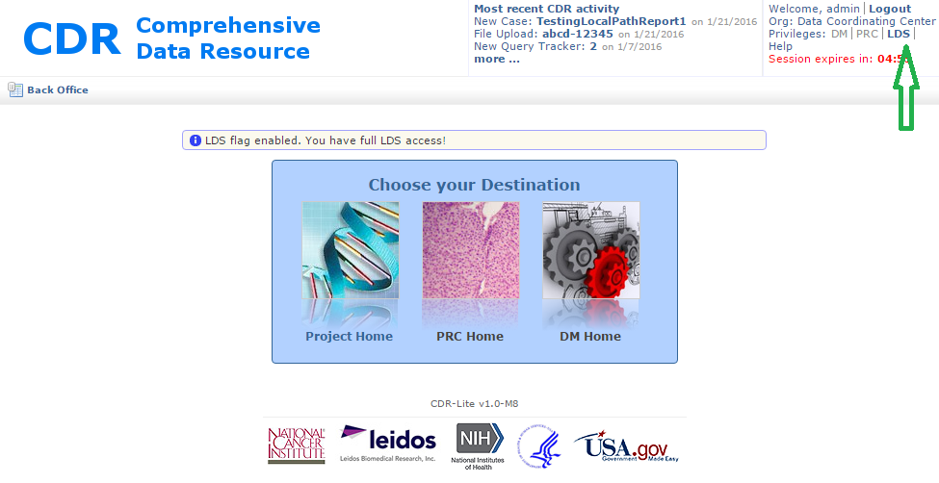

Figure 73 - Home Screen, with Green Arrow Indicating Location of LDS flag

1. If this note does not display, or the LDS text does not display in bold, then contact the CDR administrator about the privileges for this account.
2. To remove LDS access, click on the LDS letters again. The LDS letters no longer display in **bold** and all LDS fields display redacted.

# Administrative Role

The Administrative role gives a user access to many of the internals of CDR for activities including setting up a new study, adding a new organization, creating new users. The following sections describe the methods for performing most administrative actions.

## Overall Process for Creating a New Study in CDR

This is the approved process for creating a new, configured, study.

### Process

Note: This process needs to be done in the following order, as there are dependencies between the steps.

1. Login to CDR as an administrator
2. Modify the tissue list to cover those tissues in the study. (see section 7.7)
3. Modify the organization list to reflect the organizations participating in this study (see section 7.8)
4. Create the Study (see section 7.2)
5. Associate any Organizations that are BSSs with the Study. There must be at least one. (see section 7.3)
6. Create Users (see section 7.5)
7. Update the Application Settings as needed for this study (section 7.6)

## Adding a New Study Record

This is the approved process for creating a new study.

### Process

1. Login to CDR as an administrator
2. Add the DM role
3. Click on the DM Home icon
4. Click on the Vocabulary
5. Click on the Study controlled vocabulary item. This will bring up the Study List screen shown in Figure 74.

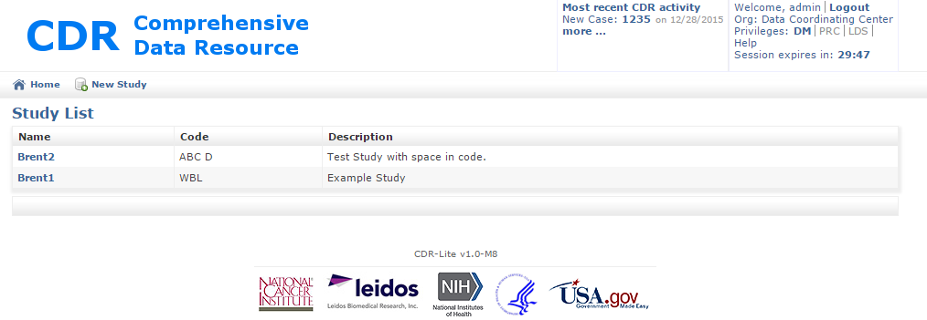

Figure 74 - Study List Screen with Two Example Studies

1. Click on the New Study icon. This will bring up the Create Study window shown in Figure 68.Figure 75.

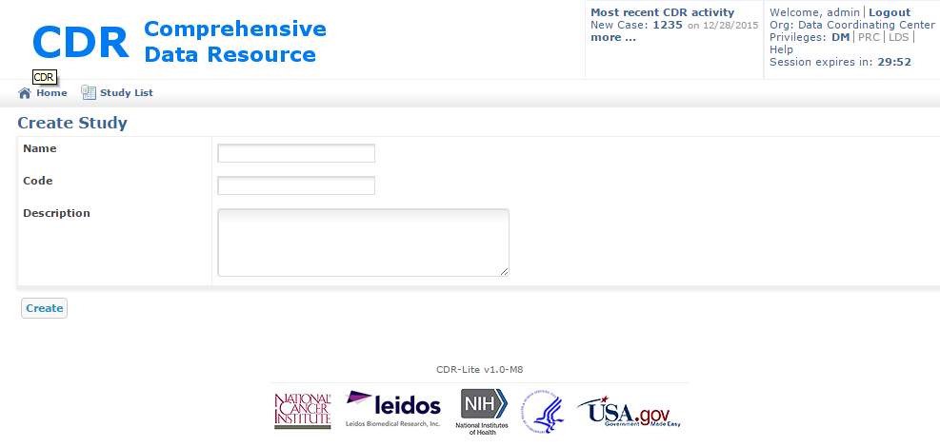

Figure 75 - Create Study Window

1. Fill out the fields as follows:

Name – Proper (long) name of Study; Study names should be unique

Code – Prefix used in creating unique identifiers for items related to this study. This prefix should be unique across all studies maintained by this instance of CDR. By convention, study codes should have no spaces and be upper case only

Description – Free text describing this study

1. Click on **Create**. This will bring up the Study List window, with the new study added.
2. To proceed without creating a study, use the back arrow on the browser, or click on the Study List icon.

## Adding an Organization

### Process

1. Log in as an administrator, and give yourself the DM privilege, Figure 76, by clicking on the letters DM in the “Privileges:” line:

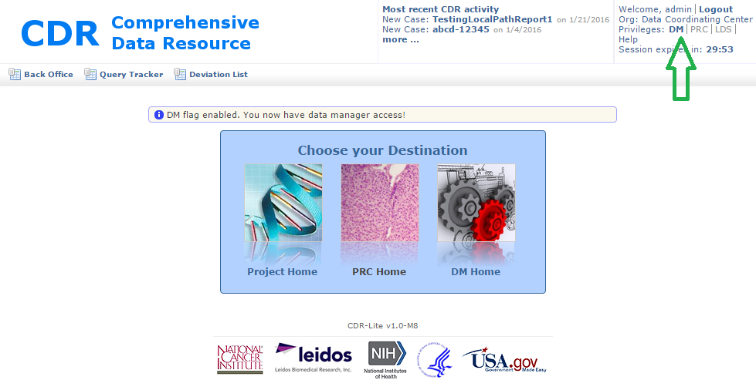

Figure 76 - Adding The DM Role in Adding an Organization

1. Go to the DM Home screen, by clicking on the image or words “DM Home.” This changes the screen to Figure 77

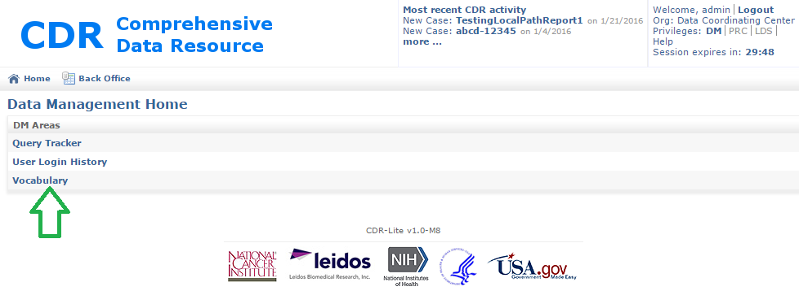

Figure 77 - Accessing Administrative Vocabulary items

1. Click on vocabulary. This changes the screen to the CDR-Lite Data Services Vocabulary and Configuration screen, Figure 78.

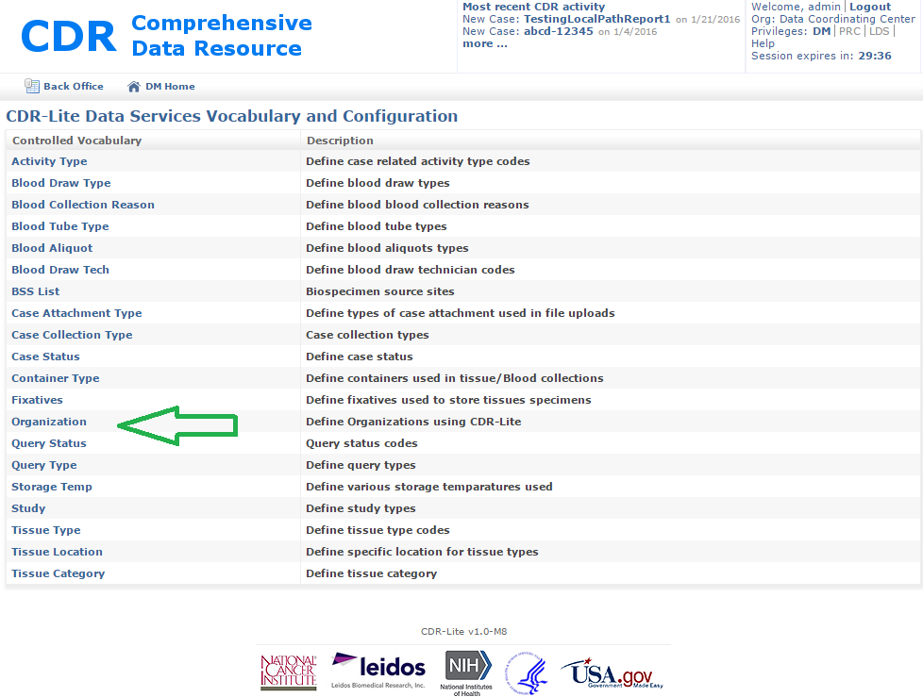

Figure 78 - CDR-Lite Data Services Vocabulary and Configuration showing Organization

1. Now, click on Organization. This brings up the Organization List screen, Figure 79.

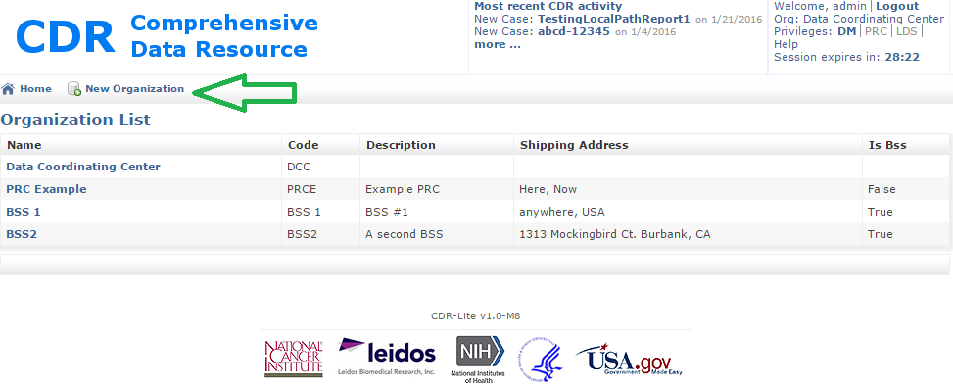

Figure 79 - Organization List, with New Organization indicated

1. Now click on “New Organization.” This brings up the Create Organization screen, Figure 80.

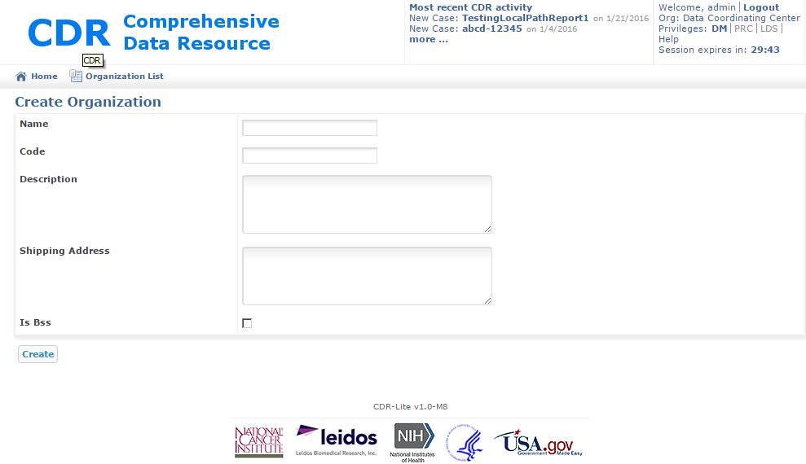

Figure 80 - Create Organization screen

1. Fill in the fields of the form as follows:
2. Name – Proper name of the organization. Typically an institute name or acronym
3. Code – Three or four characters used in labeling materials (tissues, reports…) from this organization
4. Description – Free text describing the organization; for example, the types of resources this organization offers, contact points, or other reference materials.
5. Shipping Address – Street address of the institute/organization
6. Is BSS – If this is a biospecimen source site, check this box, otherwise leave blank

**Make sure** that you identify the new Organization as a BSS appropriately!

1. Finally, click on Create.
2. If there are problems with the information entered about an organization, go to the Organization List screen, Figure 79. Click on the name of the organization with the problem information. This shows the Show Organization screen.

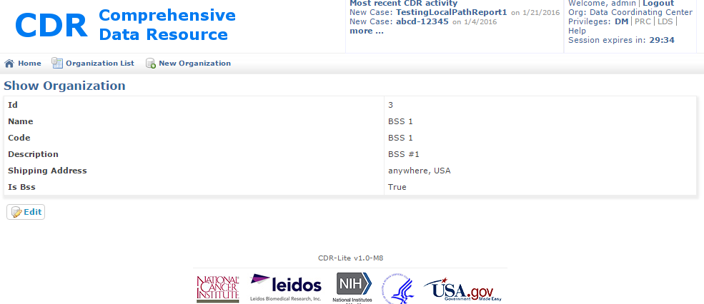

Figure 81 - Show Organization Screen

1. Confirm this is the correct organization to modify. If not, use the back button on the browser, or click on the “Organization List” icon. When satisfied, click on the **Edit** button. This shows the Edit Organization screen, Figure 80.
2. Make the appropriate changes and click on **Update**.

## Associating a Study with a BSS

After having added a study, and an Organization that is a BSS, a final step is associating the two.

### Process

1. Login to CDR as an administrator
2. Add the DM role.
3. Click on the DM Home
4. Click on the Vocabulary
5. Click on the Study controlled vocabulary item. This will bring up the screen shown in Figure 74.
6. Click on the name of the Study. This will show the screen shown in Figure 82

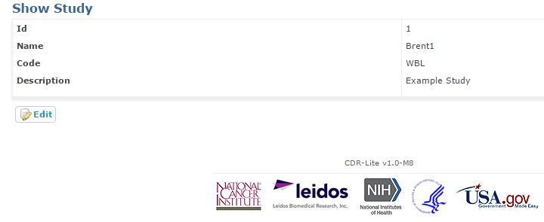

Figure 82 – Show An Individual Study Screen

1. Press the Edit button. This will show the screen in Figure 83.

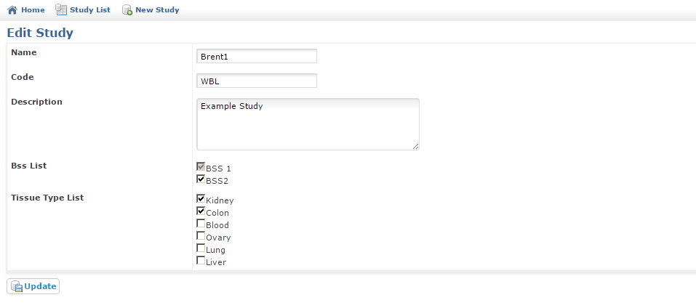

Figure 83 - Edit Study Screen

1. Update the Study fields as appropriate. The BSS List and Tissue Type List reflect values added by the administrator previously. Discussion of editing those lists is above.
2. Click on the Update button. This will show the List Sites screen.
3. If you do not wish to commit the changes, use the back arrow on the browser, or click on either the “Study List” icon, or the "Home" icon.

## Administering Users

This process adds a user to the CDR user list.

Actions available here are:

* Look up a user’s current settings
* Add/create a user
* Modify an existing user

Note: Each study needs at least three (3) users, as follows

Table 8 - Types of users required for each study

| User Role | Roles (All Roles Specified) |
| --- | --- |
| BSS User | ROLE_BSS |
| Data Manager | ROLE_DCC, ROLE_DM |
| PRC Evaluator | ROLE_DCC, ROLE_PRC |

Note: The usernames should be all lower case letters and numbers, with no spaces

### Process

1. Login to CDR as an administrator
2. Click on the “Back Office” button in the upper left.

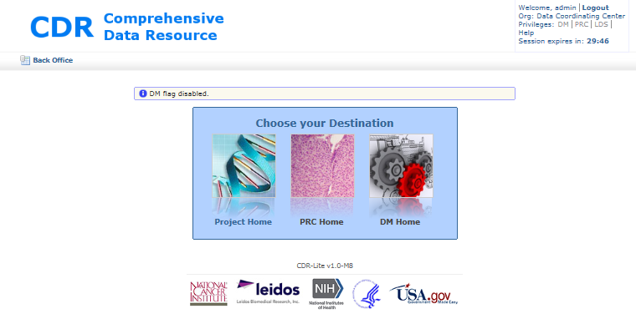

Figure 84 - CDR Project Home Destination Page

1. Once in the back office, click on the “User Administration” button

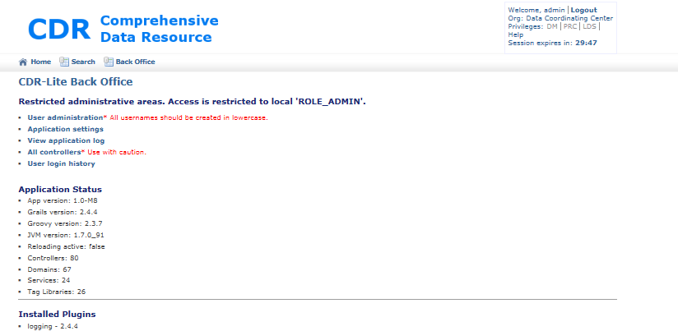

Figure 85 - CDR Back Office

1. This takes you to the Spring Security Module window.

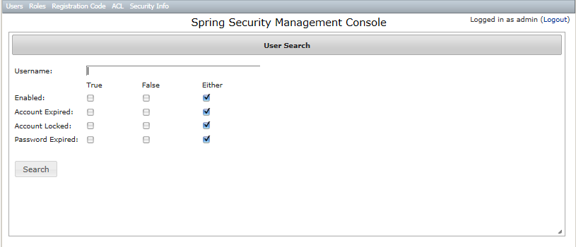

Figure 86 - Spring Security Management Console

1. To modify restrictions on an existing account:
   1. Type in the username of the account to restrict or free
   2. Press the Search button.
   3. Clicking on the check boxes causes the restrictions to change immediately.
      1. Enabled: - "True" or "Either", allows that username the option of logging in. False, they cannot login.
      2. Account Expired: True, blocks the account from further activity until enabled by an administrator. "False" or "Either", the account is available for login.
      3. Account Locked: True, blocks the account for further activity, typically because of administrative reasons. "False" or "Either", the account is available for login.
      4. Password Expired: Set either by the Administrator or by a nightly process requiring passwords be changed periodically. When "True", the next time the account is used, the user must enter a new password.
2. To create a new account:
   1. In the Spring Security Management Console (Figure 86), click on the Users menu, and select the “Create” item. This will take you to the Create User window.
   2. Now click on the “User Details” tab.

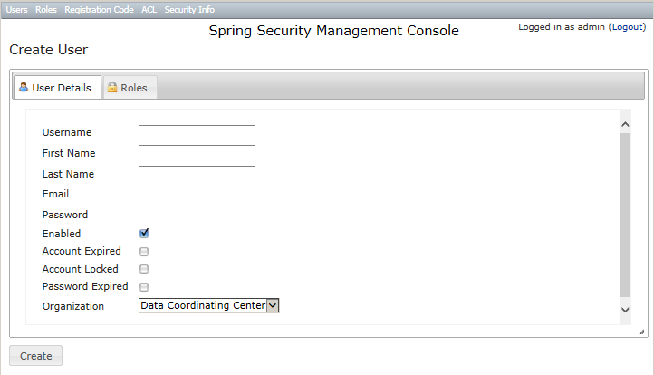

Figure 87 - Create User, User Detail

* 1. Fill out the form:
     1. Username: – user names should be all lower case letters, and have no whitespace.
     2. First Name: – The common name for the person associated with this account
     3. Last Name: – The family name for the person associated with this account
     4. Email: – Contact information for automatic alerts, warnings, and notifications
     5. Password: – First password for the user logging in.
     6. Enabled: – Checked by default; Uncheck if the account should not be available when created (e.g., creating accounts proactively)
     7. Account Expired: – if checked, the created account is blocked from use. Attempts to login get the account expired error message.
     8. Account Locked: – If checked, the created account blocks the user from making any changes.
     9. Password Expired: – If checked, once the user logs in with the password from step v, and then they will have to change the password immediately.
     10. Organization: – By default, the organization is set to Data Coordinating Center.
  2. Now click on the “Roles” tab  
     **Note: I**f you do not do this step, then no one can log in to this account!
     1. Click on the check boxes specifying the roles that this user can assume:
        1. ROLE_ADMIN – This account has administration privileges, including creating new users, modifying the vocabulary, and creating new studies.
        2. ROLE_BSS – Specify this role for a Biospecimen Source Site account, which is a place where biospecimens and data are collected.
        3. ROLE_DCC – This role is for Data Collection and Coordinating Center activities.
        4. ROLE_DM – This role is for Data Managers
        5. ROLE_LDS – This role allows the account user to see PHI data associated with a candidate/participant, such as procedure dates.
        6. ROLE_PRC – This role allows the account user to perform functions of the Pathology Resource Center.
        7. ROLE_SERVICE – Service Account, for accessing RESTful web services

**Note:** For ROLE_ADMIN, ROLE_DM, and ROLE_PRC, additionally specify ROLE_DCC. Without this, the user cannot go to the associated Home screens.

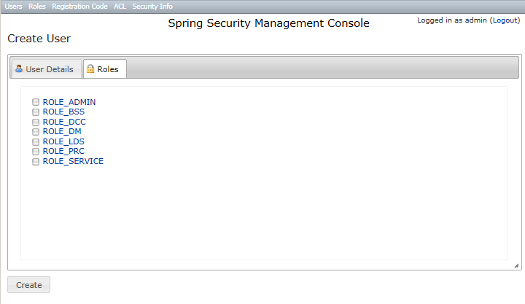

Figure 88 - Create User - Roles

1. After the information in BOTH tabs is complete, then click on the Create button in the lower left corner of the window.
2. To search for users by role
3. In the Spring Security Management Console (Figure 86), click on the Roles menu, and select the “Search” item. This will take you to
4. Click on the “Role Details” tab

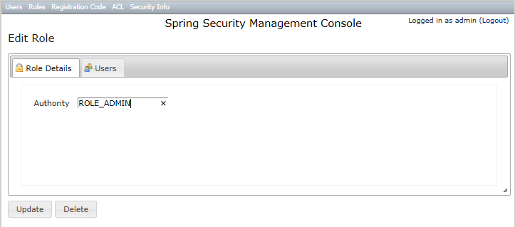

Figure 89 - Determining Which Users have a specifie Role

1. In the Authority tab, type the desired role.
2. Click on the “Update” button, and then select the “Users” tab.
3. This will display the accounts associated with that role.

## Administering Application Settings

This process configures the CDR with various installation-specific values. Some of these values will be set once, and not change. Others, such as the login bulletin, may need frequent updating in keeping the users alerted to changes or interruptions in website availability.

### Process

1. Login to CDR as an administrator
2. Click on the “Back Office” button in the upper left.
3. Once in the back office, click on the “Applications Settings” text (Figure 85)
4. CDR now displays the Appsetting List page. CDR tailors to specific studies; additional settings may become available, specific to that study. The following table describes the meaning of each setting:

Table 9 - CDR Basic Applications Settings

| Name | Description |
| --- | --- |
| HELP_EMAIL | Email address for help desk queries. The address the browser sends email when users click on the “Help” button |
| Loginbulletin | Message displayed when a user logs in to the system |
| Deny user access for Disease study | Study specific setting |
| CDRLITE_ADMIN_DISTRO | When administrative events trigger inside CDR, an email goes to this address or comma-separated list of addresses. |
| QUERY_RESPONSE_DCC_DM | Exclude responses from local DCC DM users in this list from being counted in the AR query tracker report |
| NEW_QUERY_TRACKER_DISTRO | When a new query event triggers inside CDR, an email goes to this address or comma-separated list of addresses. |
| APERIO_IMAGE_DISTRO | When a new Aperio Image is received, this triggers inside CDR, and an email goes to this address or comma-separated list of addresses. |
| APERIO_URL | URL used in connecting to the Aperio image server |
| TUMOR_STAGE_KIDNEY | Comma-separated list of applicable cancer stages. |
| TUMOR_STAGE_LUNG | Comma-separated list of applicable cancer stages. |
| TUMOR_STAGE_COLON | Comma-separated list of applicable cancer stages. |
| TUMOR_STAGE_OVARY | Comma-separated list of applicable cancer stages. |
| TUMOR_STAGE_UTERUS | Comma-separated list of applicable cancer stages. |

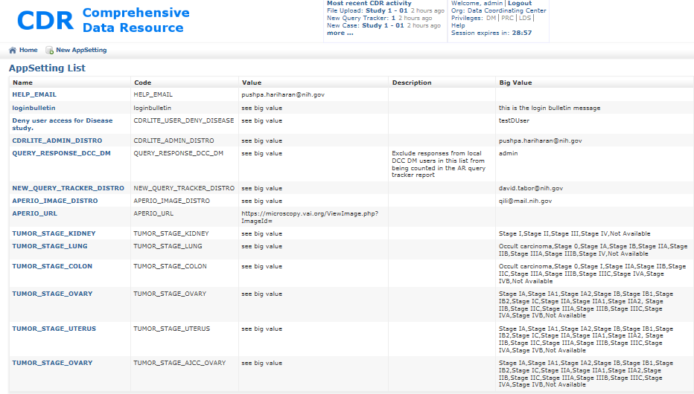

Figure 90 - CDR Applications Setting List

## Modifying Tissue List for Including New Types of Specimens

This process configures the CDR to have references to the various types of tissues collected in a study.

### Process

1. Login to CDR as an administrator
2. Add the “DM” privileges, by clicking on DM in the Privileges in the upper right corner of the screen.
3. Click on the DM Home page. When there, click on the Vocabulary item.
4. On the vocabulary page, now click on “Tissue Type.”
5. On the Tissue Type List page, look to see if all tissue types used in this study are available under the “Name” column. If not, click on the “New Tissue Type” item at the top of the list. This goes to the “Create Tissue Type” page. The fields that need to be entered are:

* Name – (required) the common name of the tissue for collecting
* Code – (required) used for code lookups by the system
* Description – (optional) text description of details of this tissue type. .

1. When complete, click **Create**.

## Modifying the list of Organizations

This process adds Organizations to the CDR. Some organizations can be designated as a BSS.

### Process

1. Login to CDR as an administrator
2. Add the “DM” privileges, by clicking on DM in the Privileges in the upper right corner of the screen.
3. Click on the DM Home page. When there, click on the Vocabulary item.
4. On the vocabulary page, now click on “Organization.”
5. Click on the “New Organization” item at the top of the list. This goes to the “Create Organization” page. The fields that need to be entered are:

* Name – (required) the common name of the Organization
* Code – (required) a unique set of letters (Upper case preferred)
* Description – (optional) text description of details of this Organization
* Shipping Address – (Required) description of the shipping address
* Is Bss – (optional) Click on this box IF this organization is a biospecimen source site

1. When complete, click **Create**.

NOTE: All studies in the CDR need at least three (3) organizations:

* Data Coordinating Center – where the information in the CDR is checked, and queries are started.
* PRC – where the collected specimen’s histology is confirmed.
* BSS – where the biospecimen is originally collected and initial information gathered.

NOTE: Associating a BSS with a study requires an additional step. See the section on Associating a BSS with a Study.

**Key Terms**

The following table provides definitions and explanations for terms and acronyms relevant to the content presented within this document.

| **Term** | **Definition** |
| --- | --- |
| BSS | Biospecimen Source Site – Institute from which human tissue is initially collected |
| CDR | Comprehensive Data Resource |
| DM | Data Management – the people and activities for data quality assurance |
| GORM | Grails Object Relational Mapping |
| Grails | A powerful computer software framework, based on the Groovy programming language, and emphasizing rapid software development of web based applications. |
| LDS | A “limited data set” is a limited set of identifiable patient information as defined in the Privacy Regulations issued under the Health Insurance Portability and Accountability Act, better known as “HIPAA.” (from http://www.hhs.gov/hipaa/for-professionals/faq/limited-data-set) |
| LIMS | Laboratory Information Management System |
| PII | Personally Identifiable Information - Individually identifiable health information |
| PHI | Protected Health Information - Health information, including demographic information; Relates to an individual’s physical or mental health or the provision of or payment for health care |
| RESTful | A type of Internet service interface typically between programs, which exchanges information. |
| SOP | Standard Operating Procedure – a detailed document describing precisely the performance of a protocol |

1. <http://biospecimens.cancer.gov/researchnetwork/lifecycle.asp>